**WATER SECURITY OUTLOOK**

**NOVEMBER 2024**

***Water Supply Information***

Water resources held by South Gippsland Water for the Tarra River Water Supply System are shown below. Only 10% of the available annual entitlement has been used from the Tarra River in the current year to date (Jul-Sep 2024). 5 ML of groundwater was pumped over the same period. This entitlement is a legal right to access water, subject to availability.

|  |  |  |  |
| --- | --- | --- | --- |
| Water Component | Maximum Annual  Entitlement | Volume Extracted 2024-25 | Volume Remaining 2024-25 |
| Tarra River | 853 ML | 84 ML | 769 ML |
| Groundwater Bore | 214.2 ML | 5 ML | 209.2 ML |

***Water Consumption***

Monthly water consumption for the Tarra River Water Supply System in the year to date was slightly lower than the average demand over the last five years. Water consumption is expected to remain close to the historical average for the remainder of the year.



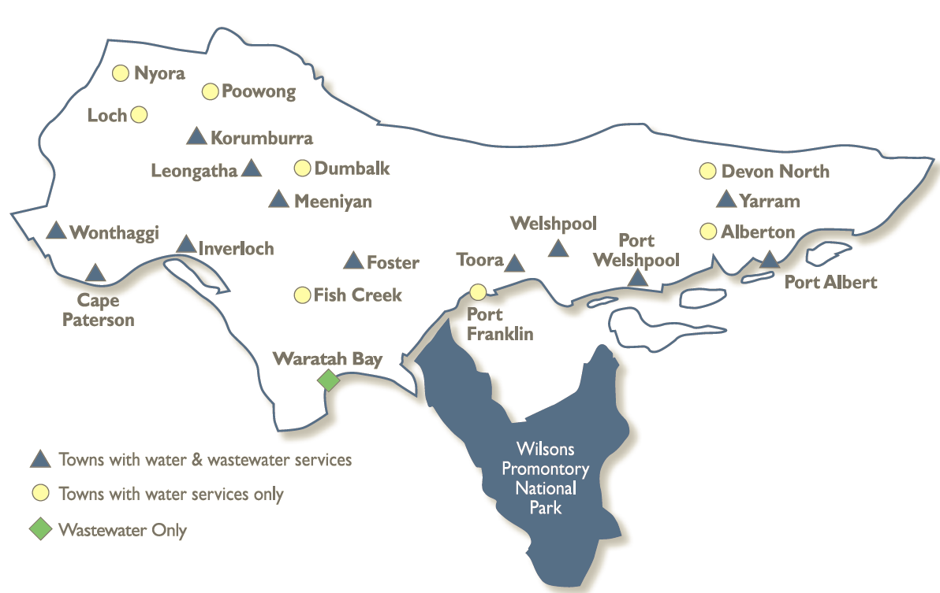

The Tarra River Water Supply System supplies water to the townships of:

* Yarram;
* Alberton;
* Port Albert; and
* Surrounding rural communities.

Primary supply is from a diversion weir on the Tarra River, with backup supply from a groundwater bore. Both sources of water are transferred to a storage basin, with a capacity of 30 ML. This storage allows water supply to be maintained during short periods of low river flow during drought.

***Tarra River Water Supply System***

South Gippsland Water

1300 851 636

www.sgwater.com.au

**WATER SECURITY OUTLOOK**

**NOVEMBER 2024**

***Climate Conditions***

Forecast climate conditions for the coming three months have considered the Bureau of Meteorology’s seasonal climate forecast for the region and local climate conditions in the year to date. Winter/spring rainfall in the year to date has consistent with the long-term average, and the Bureau’s climate outlook indicates that the next three months are likely to be slightly wetter than usual. Air temperature is forecast over the next three months to be warmer than usual for this time of year, and this trend is expected to continue beyond this period. After taking these factors into account, South Gippsland Water is forecasting on the basis of an average climate scenario.

|  |  |  |  |
| --- | --- | --- | --- |
| Chance of Exceeding Median Rainfall | Chance of Exceeding Median Maximum Temperature | This Year’s Winter/Spring Rainfall | Likely Outlook Scenario |
| 65-70% | **Greater than 80**% | **Average** | **Average** |

**Further Information:**

* The most recent records for the Tarra River upstream of the diversion weir show that it was flowing at an average of 20 ML/d during October. This is above the 5 ML/d flow threshold to activate groundwater pumping, which is used to deal with water shortages.
* The Yarram storage basin was 100% full at the end of October.
* Unregulated river flows are difficult to forecast. SGW has only forecast the next 3 months due to low forecast skill beyond 3 months. The graph is formatted to highlight low flow behaviour.
* Units are in megalitres per day (ML/d), where 1 ML is equivalent to 1 million litres

***Streamflow Outlook***

Streamflow in the Tarra River is naturally highly variable. For the year to date, streamflows have generally been at or below the historical average. Whilst precisely forecasting streamflow conditions is difficult, streamflow for the outlook period is currently expected to remain around the historical average if average climate conditions occur as expected.

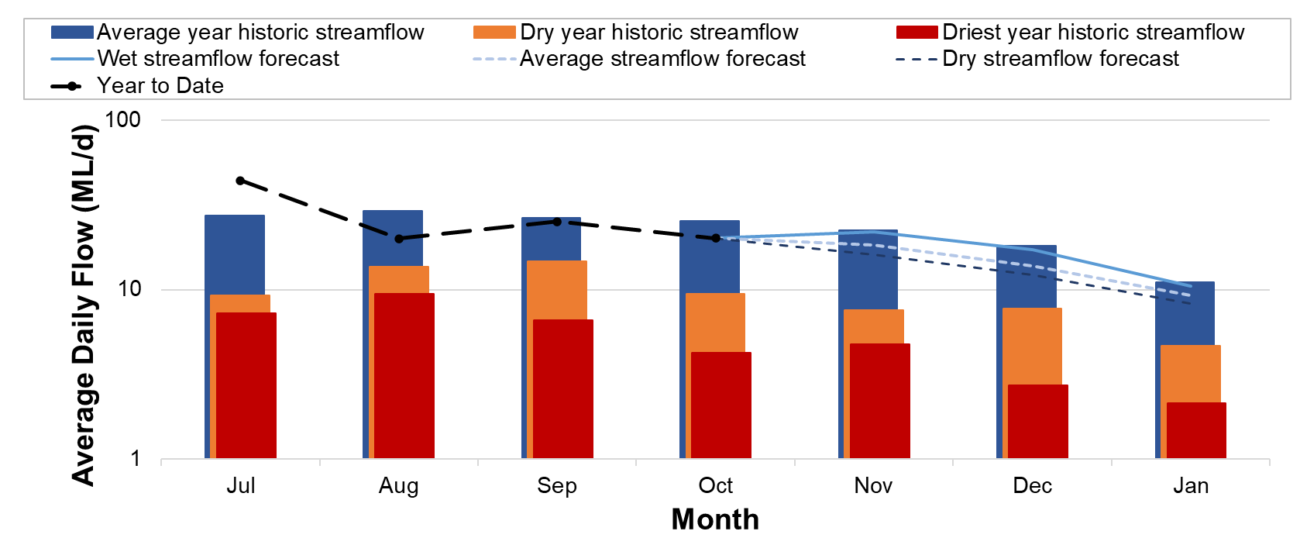

***Urban Water Restrictions Outlook***

Based on the streamflow outlook, the demands for water in the year to date, and the Bureau of Meteorology climate forecast, no water restrictions are anticipated for the remainder of the year at the current time. For the climate outlook expected, it is estimated that the groundwater bore entitlement is unlikely to be used in 2024/25. South Gippsland Water’s Permanent Water Savings Plan applies to all customers over the outlook period.

|  |  |  |  |
| --- | --- | --- | --- |
| **Climate Scenario** | **Outlook** | | |
| **1 Dec 2024** | **1 Jan 2025** | **1 Feb 2025** |
| Wet | PWSP | PWSP | PWSP |
| Average | PWSP | PWSP | PWSP |
| Dry | PWSP | PWSP | PWSP |

PWSP Permanent Water Savings Plan

**WATER SECURITY OUTLOOK**

**NOVEMBER 2024**

***Action Plan***

A list of priority actions for this supply system prior to the next update of the Urban Water Strategy in 2027 is presented below. Further information on actions can be found in our [2022 Urban Water Strategy](https://www.sgwater.com.au/about/about-us-home/urban-water-strategy/) and our [Price Submission 2023-2028](https://www.sgwater.com.au/about-us/water-plan/) publication on our website. Victoria’s [permanent water savings rules](https://www.sgwater.com.au/services/water/permanent-water-saving-rules/) are always in place in South Gippsland, saving water on an ongoing basis. For additional tips about how to save water see our [smart water advice](https://www.sgwater.com.au/smartwatermark).

|  |  |
| --- | --- |
| **Action Name** | **Timing** |
| Water awareness and efficiency programs | Ongoing |
| Leak reduction | Ongoing |
| Reuse opportunities | Ongoing |
| Update water security outlook | Every November |
| Planning for long term options as per the Urban Water Strategy | 2022-2027 |

The information provided in this water security outlook is intended as a guide only. An update will be issued if conditions change during the outlook period.

South Gippsland Water

1300 851 636

www.sgwater.com.au

***Blah***

***Water Consumption***

Lance Creek Water Supply System monthly actual water consumption versus historical consumption

***Table***

***Water Supply Information***

Water resources held by South Gippsland Water for the Lance Creek Water Supply System