**WATER SECURITY OUTLOOK**

**NOVEMBER 2024**

***Water Consumption***

Monthly water consumption for the Agnes River Water Supply System for August and September was above the average over the last five years. The July demand was close to the average demand over the last five years. It is expected that demand will be close to the historical average for the remainder of the year.



***Water Supply Information***

Water resources held by South Gippsland Water for the Agnes River Water Supply System are shown below. Only 7% of the available annual entitlement from the Agnes River has been used in the current year to date (Jul-Sep 2024). This entitlement is a legal right to access water, subject to availability.

|  |  |  |  |
| --- | --- | --- | --- |
| Water Component | Maximum Annual  Entitlement | Volume Extracted 2024-25 | Volume Remaining 2024-25 |
| Agnes River | 1,617 ML | 114 ML | 1,503 ML |

The Agnes River Water Supply System supplies water to the townships of:

* Toora
* Welshpool
* Port Welshpool
* Port Franklin

These towns are supplied from a diversion weir on Agnes River below Cook’s Dam. This dam has a capacity of 58 ML. Once diverted from the river, water is treated and then stored in three clear water storages, which have a combined capacity of 6 ML. These storages allow water supply to be maintained during short periods of low river flow during drought.

***Agnes River Water Supply System***

South Gippsland Water

1300 851 636

www.sgwater.com.au

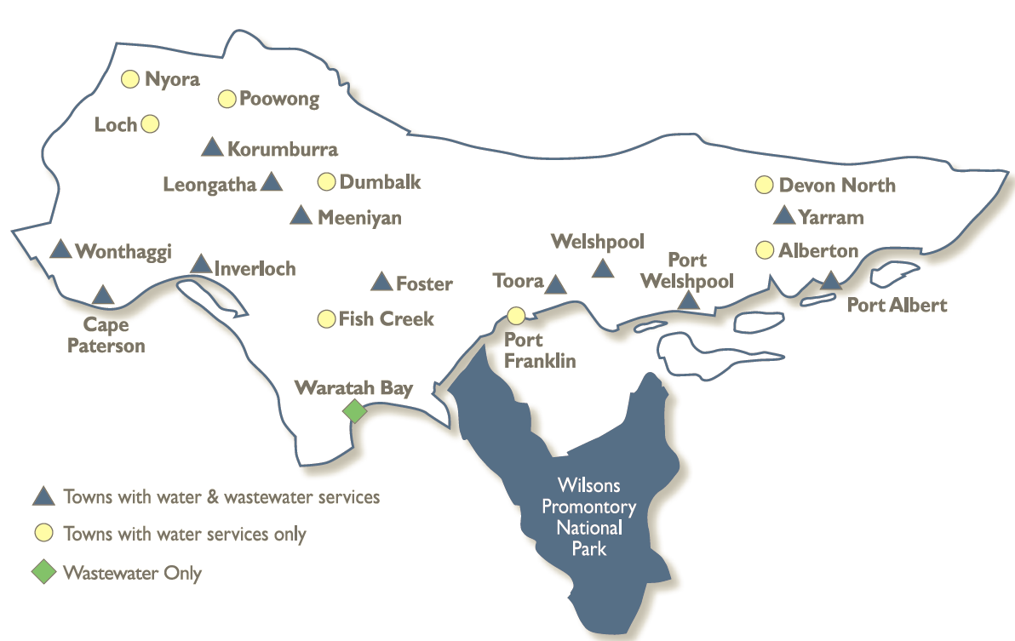

**WATER SECURITY OUTLOOK**

**NOVEMBER 2024**

***Climate Conditions***

Forecast climate conditions for the coming three months have considered the Bureau of Meteorology’s seasonal climate forecast for the region and local climate conditions in the year to date. Winter/spring rainfall in the year to date has consistent with the long-term average, and the Bureau’s climate outlook indicates that the next three months are likely to be slightly wetter than usual. Air temperature is forecast over the next three months to be warmer than usual for this time of year, and this trend is expected to continue beyond this period. After taking these factors into account, South Gippsland Water is forecasting on the basis of an average climate scenario.

|  |  |  |  |
| --- | --- | --- | --- |
| Chance of Exceeding Median Rainfall | Chance of Exceeding Median Maximum Temperature | This Year’s Winter/Spring Rainfall | Likely Outlook Scenario |
| 65-70% | **Greater than 80**% | **Average** | **Average** |

**Further Information:**

* The Agnes River Water Supply System Storages were 100% full at the end of October.
* Volumes shown in the storage outlook are start of month values in megalitres (ML), where 1 ML is equivalent to 1 million litres.

***Urban Water Restrictions Outlook***

The volume in storage outlook for the Agnes River Water Supply System for the period November 2024 to October 2025 indicates that storage levels are expected to remain high relative to water restriction triggers over the coming year under the anticipated average climate scenario. If conditions were to become much drier than expected, restrictions could occur in summer/autumn.

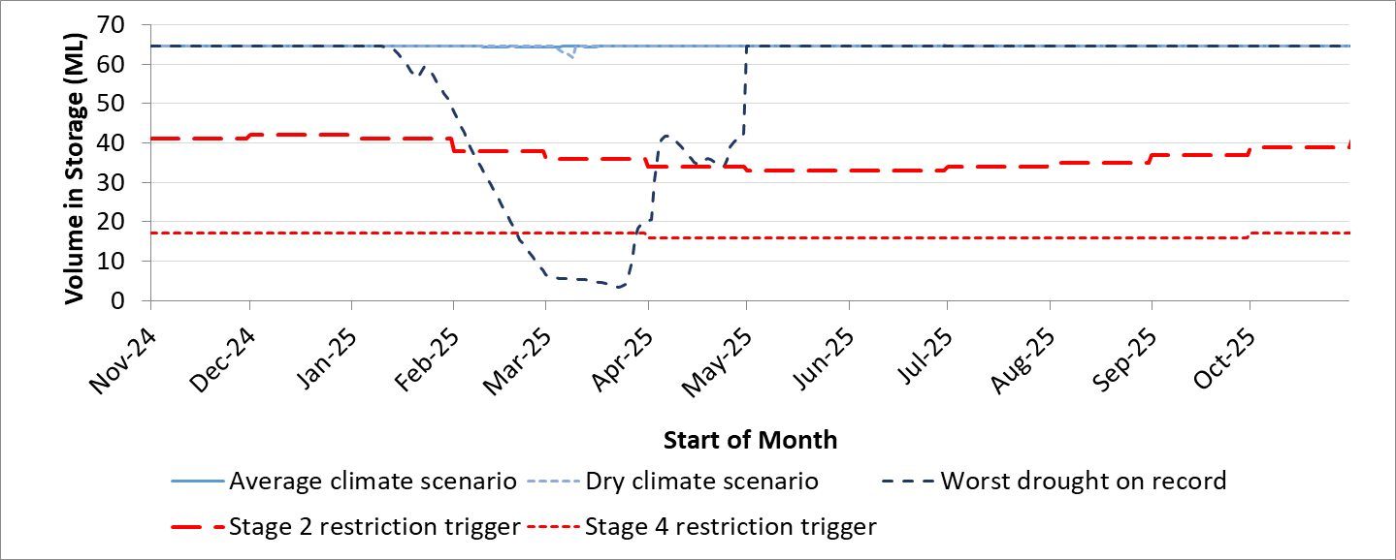

South Gippsland Water

1300 851 636

www.sgwater.com.au

**WATER SECURITY OUTLOOK**

**NOVEMBER 2024**

Based on the volume in storage outlook and the Bureau of Meteorology climate forecast, no water restrictions are anticipated for the remainder of the year at the current time. South Gippsland Water’s Permanent Water Savings Plan applies to all customers over the outlook period.

|  |  |  |  |
| --- | --- | --- | --- |
| **Climate Scenario** | **Outlook** | | |
| **1 Jan 2025** | **1 Apr 2025** | **1 Jul 2025** |
| Wet | PWSP | PWSP | PWSP |
| Average | PWSP | PWSP | PWSP |
| Dry | PWSP | PWSP | PWSP |

PWSP Permanent Water Savings Plan

***Action Plan***

A list of priority actions for this supply system prior to the next update of the Urban Water Strategy in 2027 is presented below. Further information on actions can be found in our [2022 Urban Water Strategy](https://www.sgwater.com.au/about/about-us-home/urban-water-strategy/) and our [Price Submission 2023-2028](https://www.sgwater.com.au/about-us/water-plan/) publication on our website. Victoria’s [permanent water savings rules](https://www.sgwater.com.au/services/water/permanent-water-saving-rules/) are always in place in South Gippsland, saving water on an ongoing basis. For additional tips about how to save water see our [smart water advice](https://www.sgwater.com.au/smartwatermark).

|  |  |
| --- | --- |
| **Action Name** | **Timing** |
| Water awareness and efficiency programs | Ongoing |
| Leak reduction | Ongoing |
| Reuse opportunities | Ongoing |
| Update water security outlook | Every November |
| Planning for long term options as per the Urban Water Strategy | 2022-2027 |

The information provided in this water security outlook is intended as a guide only. An update will be issued if conditions change during the outlook period.

South Gippsland Water

1300 851 636

www.sgwater.com.au

***Blah***

***Water Consumption***

Lance Creek Water Supply System monthly actual water consumption versus historical consumption

***Table***

***Water Supply Information***

Water resources held by South Gippsland Water for the Lance Creek Water Supply System