

2024 Water Security Outlooks

Annual Water Outlook

29/11/2024

Document status

|  |  |
| --- | --- |
| Client | South Gippsland Water |
| Project |  |
| Report title | Annual Water Outlook |
| Version | Final |
| Authors | Prepared by HARC and SGW |
| Project manager | Katherine Szabo (HARC), Andrew Hawes (SGW) |
| File name | SGW_2024Outlook_Final |
| Project number |  |

Document history

|  |  |  |  |  |  |
| --- | --- | --- | --- | --- | --- |
| Version | Date issued | Reviewed by | Approved by | Sent to | Comment |
| Draft A | 17/10/2024 | B.Neal (HARC) | B.Neal (HARC) | A.Hawes (SGW) |  |
| Draft B | 22/10/2024 | B.Neal (HARC) | B.Neal (HARC) | A.Hawes (SGW) | Minor amendments based on SGW comments and corrections |
| Draft C | 13/11/2024 | M Lynch  (SGW) | M Lynch (SGW) | A Hawes (SGW) |  |
| Final | 29/11/2024 | A Hawes  (SGW) | A Hawes  (SGW) | M Lynch & P Gana (SGW) | Minor amendments following review by DEECA. Inclusion of further material linked to SGW’s Urban Water Strategy |

Copyright and Limitation

This report has been produced by Hydrology and Risk Consulting Pty Ltd ACN 603 391 993 (“HARC”) for . Unless otherwise indicated, the concepts, techniques, methods and information contained within the report are the intellectual property of HARC and may not be reproduced or used in any form by third parties without the express written consent of HARC and .

The report has been prepared based on the information and specifications provided to HARC by . HARC does not warrant this document as being complete, current or free from error and disclaims all liability for any loss, damage, costs or expenses (including consequential losses) relating from this report. It should only be used for its intended purpose by and should not be relied upon by third parties.

Copyright © Hydrology and Risk Consulting Pty Ltd ACN 603 391 993. All rights reserved.

Executive Summary

South Gippsland Water (SGW) currently manages eight water supply systems that provide water to 22 individual towns and locations. This document describes the expected outlook for these systems over the coming summer season, with the likelihood of restrictions in each system summarised in Table 1. In most instances, the forecasts below reflect the 12-month period from the start of November 2024 to the end of October 2025. The forecast period for run-of-river systems is 3 months from the start of November 2024 to the end of January 2025, reflecting the period over which the forecast has an acceptable level of uncertainty. The Little Bass and Coalition Creek supply systems that previously supplied Korumburra, Poowong, Loch and Nyora are not currently being used, other than to supply very small volumes of non-residential water, and therefore have not been listed in Table 1.

The following general statements can be made about the SGW systems over the outlook period under the forecast average climate conditions across the region:

* Restrictions are not considered likely or certain for any supply systems;
* For Fish Creek, restrictions are not expected under the anticipated average climate scenario, but could still be possible in late summer and autumn if conditions were to become drier than anticipated. Fish Creek (Battery Creek Storage) is a small system and can change quickly, both in response to rainfall, and in the event of sustained dry conditions for only a few months.
* For Toora, the likelihood of restrictions is assessed as rare, with restrictions projected to only occur if conditions were to become drier than indicated by the Bureau of Meteorology’s climate forecast and recent climate conditions.
* The systems with low storage capacity relative to demands (Dumbalk, Meeniyan and Yarram) have been assigned a restriction likelihood of very rare, as the recent streamflow conditions, as well as the forecast climate conditions, suggest streamflows will remain near average and well above South Gippsland Water’s restriction triggers.

Additional supply risks for South Gippsland Water’s supply systems include water quality risks (blue-green algae risk) in Lance Creek Reservoir. This potential risk is managed at Lance Creek Reservoir through the use of seasonal supply from the Greater Yarra System – Thomson River Pool (Melbourne Water Supply System). Algaecides are used when necessary to treat and limit the extent of blue-green algae blooms within Lance Creek reservoir. This is a preventative measure which is non-harmful to humans and preserves environmental health of all organisms beyond the targeted blue-green algae species. There is also a minor blue-green algae risk in Leongatha. Extreme events or emergencies such as bushfires in our catchments, major loss of power supply or water contamination could require the implementation of restrictions to manage water demands. Bushfire risks are low across most of South Gippsland Water’s supply catchments due to low vegetation cover (less than ~30%) in these catchments, except for the catchments supplying Yarram, Toora and Foster.

Table 1 Outlook Summary

|  |  |  |  |
| --- | --- | --- | --- |
| Supply Sources | Towns Supplied | Outlook Period | Likelihood of Restrictions (1) |
| Ruby Creek Reservoirs | Leongatha, Koonwarra | 1 Nov 2024 to 31 Oct 2025 (12 months) | Very Rare |
| Lance Creek Reservoir and the Melbourne Water Supply System | Wonthaggi, Cape Paterson, Inverloch, Korumburra, Poowong, Loch, Nyora | 1 Nov 2024 to 31 Oct 2025 (12 months) | Very Rare |
| Tarwin River East Branch | Dumbalk | 1 Nov 2024 to 31 Jan 2025 (3 months) | Very Rare (to end of Jan 2025) |
| Tarwin River | Meeniyan | 1 Nov 2024 to 31 Jan 2025 (3 months) | Very Rare (to end of Jan 2025) |
| Deep Creek Reservoir and Foster Dam | Foster | 1 Nov 2024 to 31 Oct 2025 (12 months) | Very Rare |
| Battery Creek Reservoir | Fish Creek | 1 Nov 2024 to 31 Oct 2025 (12 months) | Possible |
| Cook’s Dam (Agnes River) | Toora, Welshpool, Port Welshpool, Port Franklin, Barry Beach | 1 Nov 2024 to 31 Oct 2025 (12 months) | Rare |
| Tarra River and groundwater | Yarram, Alberton, Port Albert, Devon North | 1 Nov 2024 to 31 Jan 2025 (3 months) | Very Rare (to end of Jan 2025) |

(1) Explanation of the likelihood classification is available in Table 8

Contents

1. Introduction 1

1.1 Climate Summary 3

1.1.1 Victoria’s climate and streamflow in the longer-term context 3

1.1.2 Recent Climatic Conditions in South Gippsland 3

1.1.3 Recent Streamflow Conditions in South Gippsland 7

2. Current Water Resource Position 8

3. Climate Outlook 19

4. Forward Outlook 22

5. Short Term Action Plan 28

# Introduction

South Gippsland Water (SGW) currently manages eight water supply systems that provide water to 22 individual towns and locations, listed in Table 1. A locality map of the towns supplied by SGW is shown in Figure 1. The Little Bass and Coalition Creek supply systems that previously supplied Korumburra, Poowong, Loch and Nyora are not currently being used, other than to supply small volumes of non-residential water, and are therefore not considered further in this outlook.

Current raw water demand is presented in Table 2 to indicate the relative size of each supply system.

Table 2 Water Supply Systems managed by SGW

|  |  |  |
| --- | --- | --- |
| Supply System | Towns Supplied | Current average raw water demand (ML/year) (1) |
| Lance Creek | Wonthaggi, Cape Paterson, Inverloch | 1,630 |
| Poowong, Loch, Nyora | 280 |
| Korumburra | 790 |
| Ruby Creek | Leongatha, Koonwarra | 1,670 |
| Tarwin River | Meeniyan | 51 |
| Tarwin River East Branch | Dumbalk | 17 |
| Battery Creek | Fish Creek | 110 |
| Deep Creek/Foster Dam | Foster | 170 |
| Agnes River | Toora, Welshpool, Port Welshpool, Port Franklin, Barry Beach Port | 520 |
| Tarra River | Yarram, Alberton, Port Albert, Devon North | 440 |
| **TOTAL** | | 5,700 |

(1) Taken from the SGW’s Urban Water Strategy (2022), average annual raw water demand estimated at current level of population and industrial development over a long-term climate sequence (50 years) to account for differences in water demand in wet, average and dry years.

SGW prepared an update to its [Urban Water Strategy](https://www.sgwater.com.au/about/about-us-home/urban-water-strategy/) (UWS) in 2022. This document, published on SGW’s website, outlines SGW’s long term plan to balance the supply of water to meet the region’s residential, business, industry and community water needs. The UWS identifies systems where future water supplies may need to be enhanced in order to meet the growing demands and be resilient to climate change. The UWS is complemented by a [Drought Preparedness Plan (DPP)](https://www.sgwater.com.au/wp-content/uploads/2014/04/SGW-Drought-Preparedness-Plan-2022.pdf) which provides SGW with a ready reference for operational guidance in times of drought. The DPP details the actions SGW will take in order to prepare for and to respond to periods of water scarcity. This Water Security Outlook is one such action.

The 2022 UWS includes 60 actions, of which SGW has completed 9 to date. A further 32 of these actions are currently underway. Action 4.6, which looks at purchasing additional Bulk Water Entitlement from Melbourne Water has been delayed. This is due to upcoming reforms to bulk water entitlements held within the connected Melbourne Supply System (South-Central reforms), which will alter approaches for obtaining additional water entitlements through this system. Action 4.14, an investigation into feasibility of digital meters to customers in Fish Creek to understand leakage and non-revenue water losses has also been delayed. This is due to a change in approach to leak detection being planned for transfer and distribution mains in key towns using digital meters and flow balances, rather than digital meters for customers in Fish Creek.

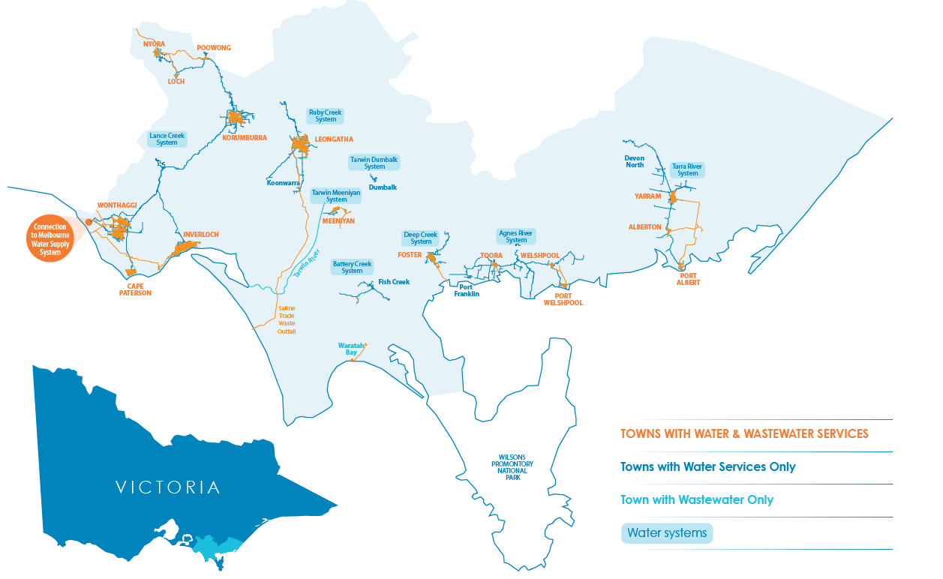

Figure 1 Locality map of SGW’s supply systems

## Climate Summary

### Victoria’s climate and streamflow in the longer-term context

Victoria’s climate and streamflow is highly variable, but alongside this variability we have experienced a warming and drying trend over recent decades.

In comparison to historical conditions, we are already experiencing trends toward:

* Higher temperatures and more hot days;
* Reductions in rainfall during the cooler months;
* In some locations, increases in rainfall during the warmer months and during extreme, short-duration rainfall events; and,
* In many catchments, a shift in the streamflow response to rainfall, with typically less streamflow generated for a given amount of rain.

Some of the rainfall decline in the cooler months can be attributed to increases in greenhouse gas concentrations in the atmosphere. During the cooler months we have been getting less rainfall from low pressure systems and frontal systems.

In the future, over the longer term we can expect:

* the rainfall reductions during the cooler months to persist;
* possible increases in extreme rainfall events;
* increases in potential evapotranspiration due to higher temperature and lower relative humidity;
* reductions in streamflow because of less rainfall and higher potential evapotranspiration; and
* the streamflow response to rainfall to no longer remain the same, and generally decline.

Victoria’s climate will continue to be variable with wet years and dry years, against a background drying trend. With a warmer future and projections of declining water availability, we can expect more frequent and severe droughts in coming decades and increases in extreme rainfall events.

The Victorian Government is investing in further research to better understand how Victoria’s climate is changing and the water resource implications, through the Victorian Water and Climate Initiative. More information on the observed changes and longer-term future climate and water projections can be found at:  
<https://www.water.vic.gov.au/climate-change>

### Recent Climatic Conditions in South Gippsland

Over the past 12 months, rainfall across the South Gippsland region has been close to the long-term average, as shown in Figure 2. Rainfall in most towns has been 80-100% of the Bureau of Meteorology’s long-term average (from 1961-1990), with slightly wetter conditions for Toora, Yarram, and surrounding towns, which experienced rainfall 100-120% of the long-term average over the last 12 months.

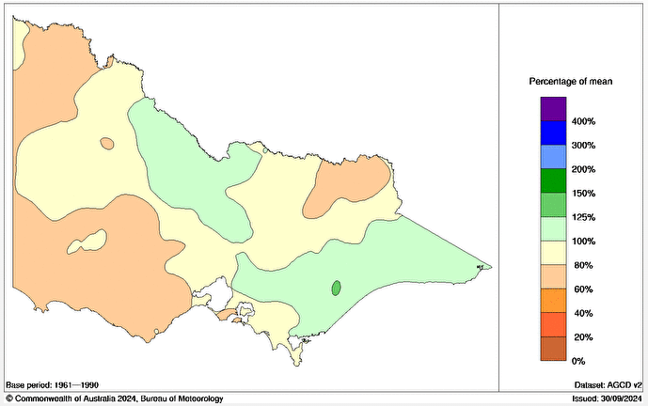

Figure 2 Rainfall percentages relative to mean over the period 1 October 2023 to 30 September 2024 (<http://www.bom.gov.au/climate/maps/rainfall>)

Seasonal rainfall conditions over the past year at two representative rainfall sites in South Gippsland are shown in Figure 3 for Korumburra and Yarram. This chart compares the recent rainfall to the long term monthly average rainfall and confirms the observations made for the region above. Over the past 12 months, rainfall has been variable, with relatively dry conditions for much of this year’s winter and spring, except for average to high rainfall in July. Over winter spring (July to September 2024), rainfall across the South Gippsland region has been close to the long-term average, as shown in Figure 4, with the exception of Wonthaggi, Cape Patterson and Inverloch which experienced less than average winter-spring rainfall.

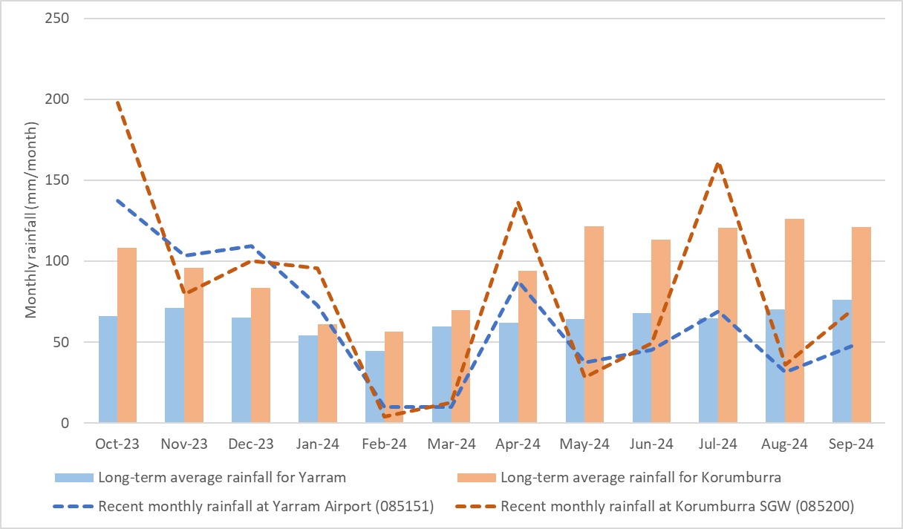

Figure 3 Recent and long-term average monthly rainfall in Korumburra and Yarram

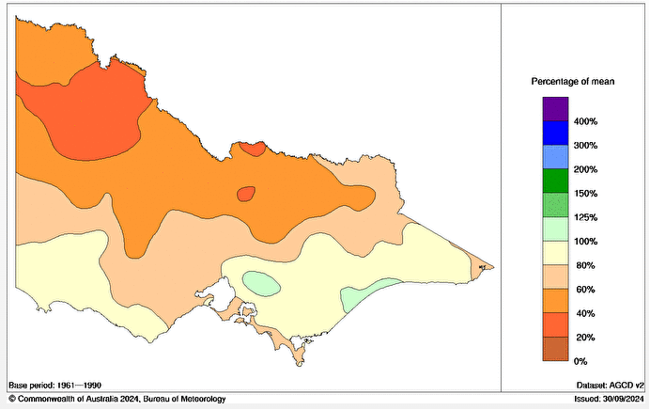

Figure 4 Rainfall percentages relative to mean over the period 1 July 2023 to 30 September 2024 (<http://www.bom.gov.au/climate/maps/rainfall>)

A comparison of rainfall over the last 12 months relative to average annual rainfall over different climate reference periods is shown in Table 3. Average rainfall over the period July 1975 to date is regarded by the State Government as being broadly representative of current climate averages, with the period July 1997 to date offered by the State Government as an alternative, drier representation of current climate averages.

Rainfall over the last twelve months has been 12% lower than that experienced on average at Korumburra since 1975, whilst at Yarram the rainfall over the last twelve months has been 8% higher than that experienced on average since 1975.

Table 3 Recent rainfall relative to average rainfall conditions over different historical periods

|  |  |  |  |  |
| --- | --- | --- | --- | --- |
| Location | Last 12 months’ rainfall  October 2023 to September 2024 (mm) | Last 12 months’ rainfall relative to… | | |
| Average July 1975 to date | Average July 1997 to date | Lowest on record |
| Korumburra | 970 | 12% lower | 10% lower | 18% higher |
| Yarram | 760 | 8% higher | 18% higher | 72% higher |

### Recent Streamflow Conditions in South Gippsland

Streamflow conditions across South Gippsland are illustrated in Figure 5 using two representative streamflow sites on the Tarwin River East Branch at Dumbalk North and on the Tarra River at Fischers. This chart compares the recent streamflow observations with their long-term average monthly streamflow characteristics. It demonstrates that flow conditions were higher than average in July 2024 in response to higher rainfall in that month, both otherwise below average streamflows have prevailed for most of 2024 to date. This is broadly consistent with recent rainfall observations.

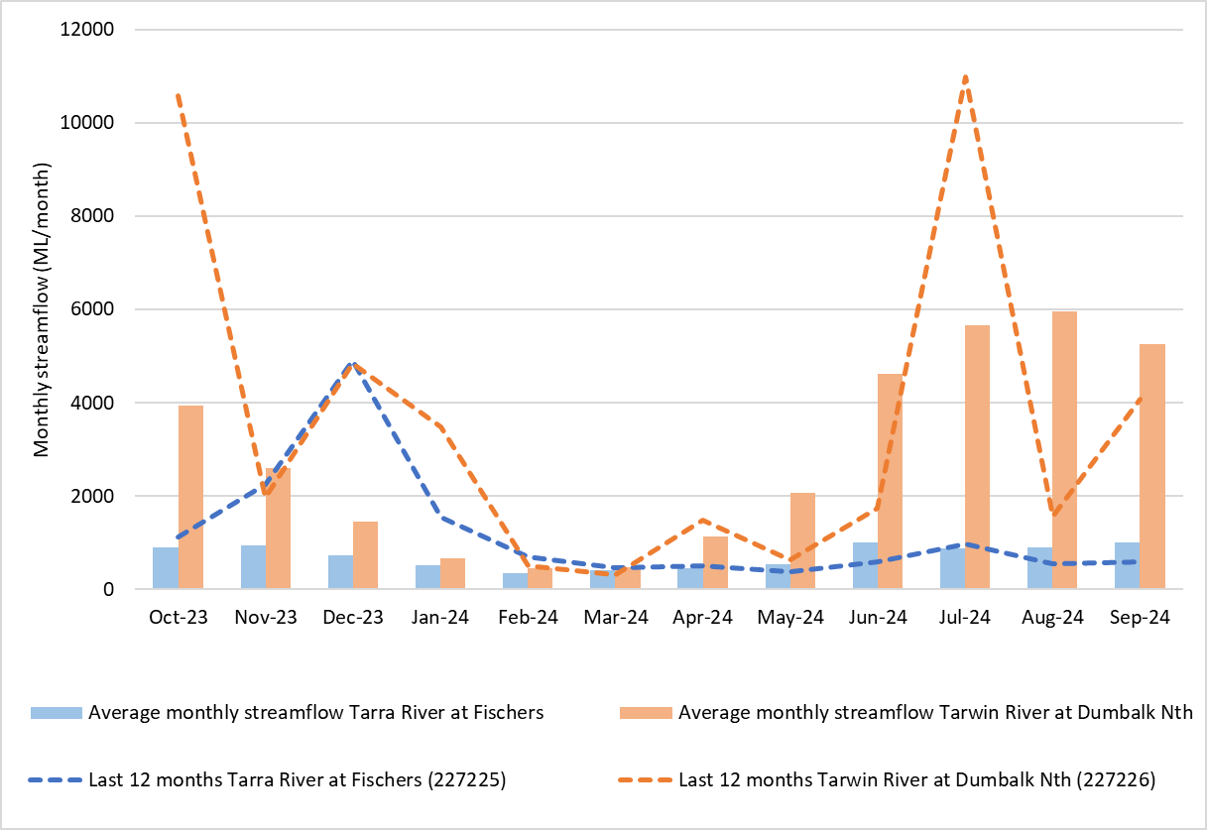

Figure 5 Recent and long-term average monthly streamflow for example sites on the Tarra River and Tarwin River

# Current Water Resource Position

This section provides a summary of the current position of SGW’s water supply systems. Table 4 summarises each of SGW’s systems, with information on the major customers and water sources. For completeness, this table also provides a comprehensive list of all legal entitlements, however it should be noted that not all of these water sources are actively used. Some are entitlements that require significant infrastructure upgrades for them to be used. The year-to-date extraction volumes listed in Table 4 cover the period from the beginning of July until the end of September 2024.

For the Lance Creek Water Supply System, in the year to date South Gippsland Water has been allocated 31% of its entitlement from the Greater Yarra System – Thomson River Pool (Melbourne Water Supply System), which equates to 310 ML. Based on projections by Melbourne Water, this year’s allocation is expected to increase over the coming months, even under the forecast dry climate conditions (see Section 3) over the outlook period. South Gippsland Water has also carried over 1,737 ML of unused allocations from previous years to the current year, providing a significant supply buffer in this supply system if conditions were to become drier than expected.

In the year to date no water has been extracted from supplementary groundwater sources at Leongatha and 5 ML of supplementary groundwater supply has been provided at Yarram. The remainder of these supply sources remain in reserve and can be drawn upon if required.

Table 4 System Summary – Water Supply Connections, Major Customers and Available Entitlements

|  |  |  |  |  |  |  |  |  |
| --- | --- | --- | --- | --- | --- | --- | --- | --- |
| Supply System | Towns Supplied | Number of connections | Major customers | Primary Bulk Entitlement | | | Supplementary water sources | |
| Annual entitlement (ML) | Volume extracted 2024‑25 YTD (ML) | Volume remaining 2024-25 (ML) | Annual entitlement  (ML) | Volume extracted 2024‑25 YTD (ML) |
| Ruby Creek | Leongatha, Koonwarra | 3,436 | Saputo Dairy Australia | 2,476 | 335 ML | 2,141 ML | Share of 715.3 ML from groundwater | 0 |
| Lance Creek | Wonthaggi, Cape Paterson, Inverloch, Korumburra, Poowong, Loch, Nyora | 14,404 | Burra Foods Australia, Kilcoy Global Foods, and GBP Australia (Poowong Abattoir) | 3,800 ML from Lance Creek Reservoir | 645 ML from Lance Ck | 3,155 ML from Lance Creek | 1,000 ML from Melbourne Water Supply System: 31% year to date seasonal allocation (310 ML) plus 1,728 ML (net) carried over from previous year | 123 ML from Melbourne Water Supply System |
| Tarwin River East Branch | Dumbalk | 109 |  | 100 | 3 ML | 97 ML |  |  |
| Tarwin River | Meeniyan | 278 |  | 200 | 12 ML | 188 ML |  |  |
| Deep Creek / Foster Dam | Foster | 953 |  | 326 | 51 ML | 275 ML |  |  |
| Battery Creek | Fish Creek | 209 |  | 251 | 26 ML | 225 ML |  |  |
| Agnes River | Toora, Welshpool, Port Welshpool, Port Franklin, Barry Beach Port | 1,133 | Esso, ViPlus | 1,617 | 114 ML | 1,503 ML |  |  |
| Tarra River | Yarram, Alberton, Port Albert, Devon North | 1,883 |  | 853 | 84 ML | 769 ML | 214.2 ML from groundwater | 5 ML |

The volume in storage across the SGW systems is summarised in Table 5. All storages are currently full, except for Foster Dam, Lance Creek Reservoir, and two of the Leongatha storages.

Table 5 Current Water Resource Position

|  |  |  |  |  |
| --- | --- | --- | --- | --- |
| Supply System | Storage | Storage capacity (ML) | Current storage volume (ML) at end October 2024 | % of Full Supply Volume |
| Little Bass | Little Bass Reservoir (1) | 218 | N/A | N/A |
| Korumburra | Coalition Creek Reservoir (1) | 143 | N/A | N/A |
| Ness Gully Reservoir (1) | 73 | N/A | N/A |
| Bellview Creek Reservoir (1) | 359 | N/A | N/A |
| Leongatha | Western Reservoir | 1,137 | 1,137 | 100% |
| Hyland Reservoir | 671 | 610 | 91% |
| No.2 Reservoir | 84 | 60 | 71% |
| No.1 Reservoir | 15 | 15 | 100% |
| Lance Creek | Lance Creek Reservoir | 4,200 | 3,700 | 88% |
| Fish Creek | Battery Creek Reservoir | 119 | 119 | 100% |
| Foster | Deep Creek Reservoir | 5 | 5 | 100% |
| Foster Dam | 233 | 201 | 86% |
| Raw Water Basin | 27 | 27 | 100% |
| Agnes River | Cook’s Dam | 59 | 59 | 100% |
| Tarra River | Yarram Basin | 30 | 30 | 100% |

(1) storage not in use, other than for minor supply to non-urban customers. These storages are currently maintained at target operational water levels below full supply volume.

N/A = not applicable.

The volume of water consumed over the year to date is compared below to the average demand over the past five years for each system. Water usage in the past 5 years is also compared against projected use as highlighted in the [Urban Water Strategy](https://www.sgwater.com.au/about/about-us-home/urban-water-strategy/). Toora, Meeniyan and Lance Creek are the only supply systems where water consumption has consistently been above average in the year to date. The higher demand year to date for Lance Creek is partly due to increase water use from one of the major industrial customers. The higher demand for Meeniyan is expected as demands fluctuate in a small supply system. Demand for Leongatha has been reduced in the 2024 storage outlook relative to previous years due to a reduction in recent historical and forecast water consumption by major customers. In line with the forecast average climate conditions, consumption for all supply systems is expected to be close to the long-term average for the remainder of the year.

The [Urban Water Strategy](https://www.sgwater.com.au/about/about-us-home/urban-water-strategy/) provides further information on the expected growth in residential, stock and domestic, major industrial and other non-residential demands over a long-term (50 year) planning horizon for a range of possible future climate scenarios. South Gippsland Water tracks water use on an ongoing basis to monitor for growth.

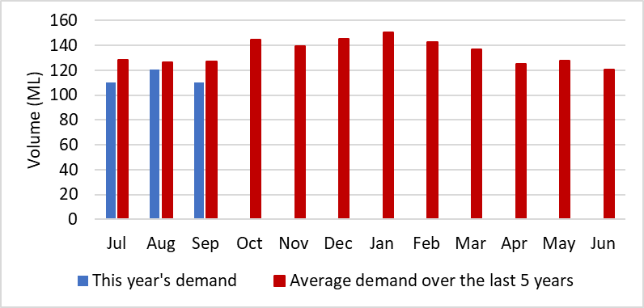

Figure 6 Water consumption in Leongatha

Figure 7 Comparison of annual water demand in Leongatha to long term demand forecasting

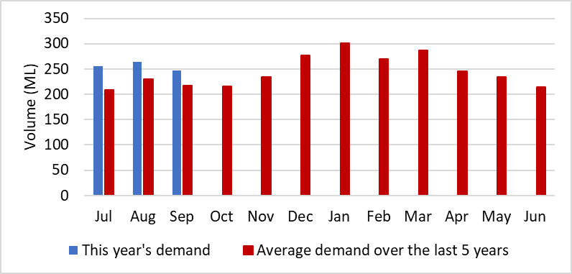

Figure 8 Water consumption in the Lance Creek system

Figure 9 Comparison of annual water demand in Lance Creek to long term demand forecasting

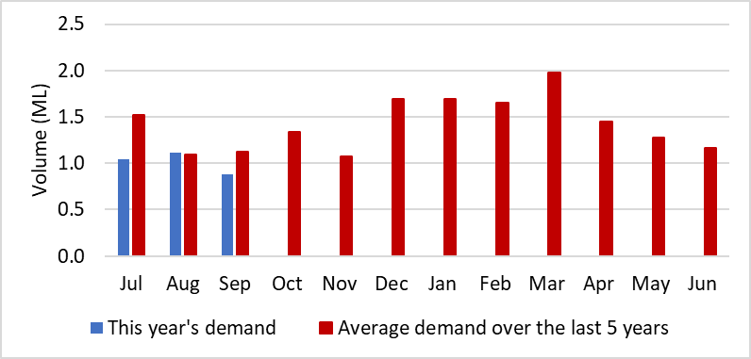

Figure 10 Water consumption in Dumbalk

Figure 11 Comparison of annual water demand in Dumbalk to long term demand forecasting

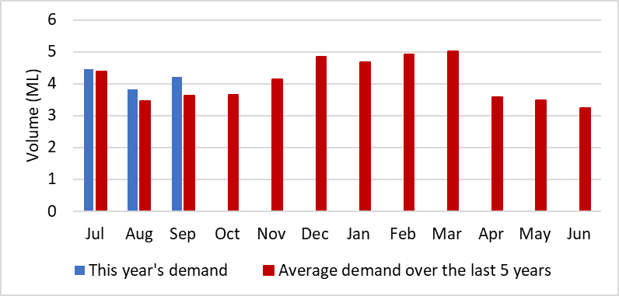

Figure 12 Water consumption in Meeniyan

Figure 13 Comparison of annual water demand in Meeniyan to long term demand forecasting

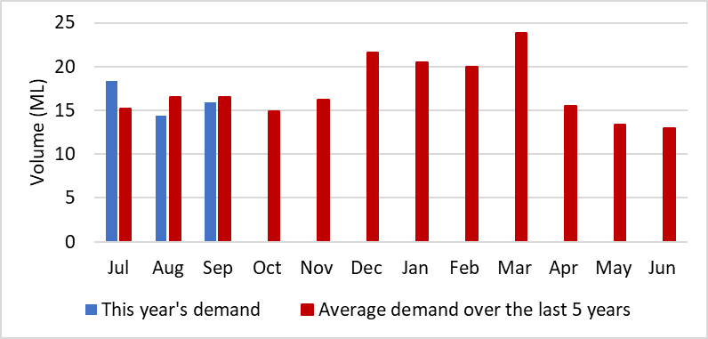

Figure 14 Water consumption in Foster

Figure 15 Comparison of annual water demand in Foster to long term demand forecasting

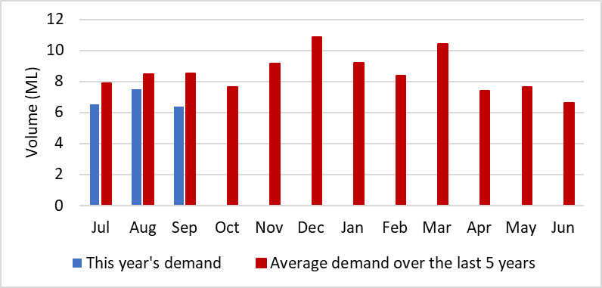

Figure 16 Water consumption in Fish Creek

Figure 17 Comparison of annual water demand in Fish Creek to long term demand forecasting

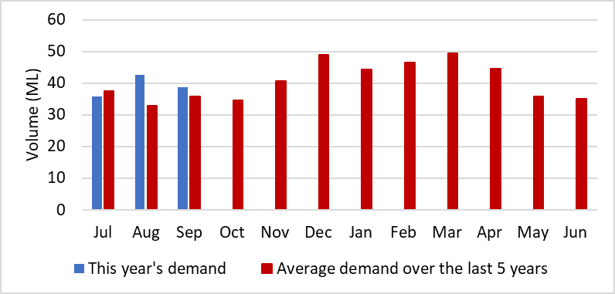

Figure 18 Water consumption in Toora

Figure 19 Comparison of annual water demand in Toora to long term demand forecasting

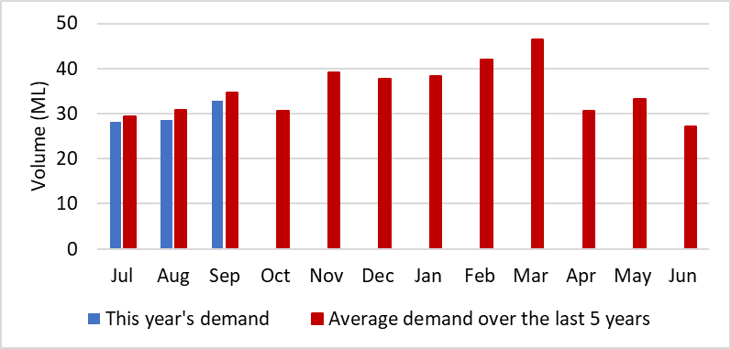

Figure 20 Water consumption in Yarram

Figure 21 Comparison of annual water demand in Yarram to long term demand forecasting

# Climate Outlook

The Bureau of Meteorology’s seasonal climate forecasts have been obtained for the December to February three-month period.

Across the region, rainfall is anticipated to be slightly wetter than usual, with a forecast 65-70% chance of exceeding median rainfall conditions during December to February (as shown in Figure 22).

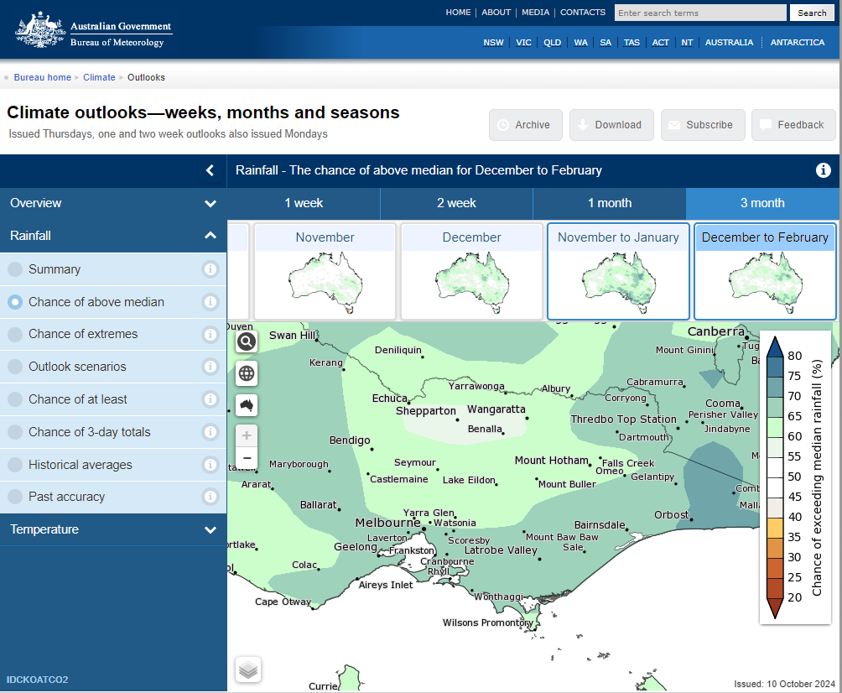

Figure 22 Chance of above median rainfall for December to February (<http://www.bom.gov.au/climate/ahead/>) issued 15 October 2024

The maximum daytime temperature across the region is forecast to be hotter than usual from December to February, as indicated in Figure 23. The there is an 80% likelihood of above median temperatures across all of South Gippsland.

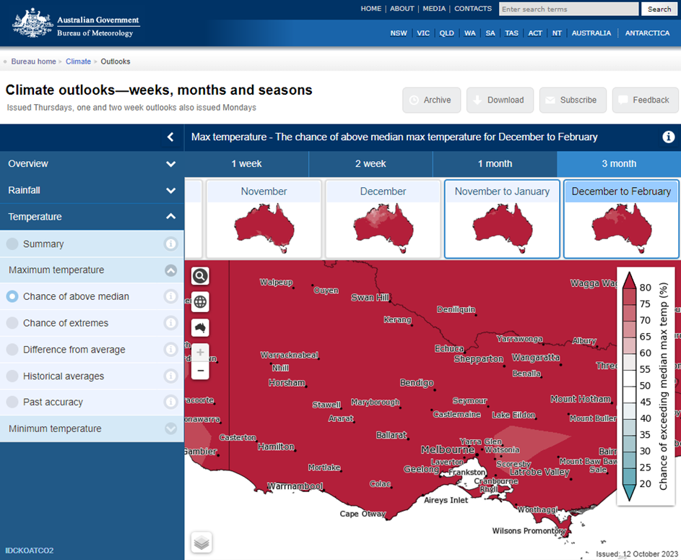

Figure 23 Chance of above median maximum temperature for December to February (<http://www.bom.gov.au/climate/ahead/>) issued 15 October 2024

The forecast climate conditions for South Gippsland have been developed based on the Bureau’s forecast for the region and the local climate conditions in the year to date. Table 6 summarises the climate outlook across SGW’s systems and specifies the scenario assumed for the Annual Water Outlook for each system, based on the assumption that:

* Wet conditions have >80% chance of exceeding median rainfall
* Average conditions have >40% to <80% chance of exceeding median rainfall
* Dry conditions have <40% chance of exceeding median rainfall

Climate influences on south-eastern Australia this year:

* A neutral state for the El Nino Southern Oscillation (ENSO) with a La Nina watch. If a La Nina event were to develop, it is forecast to be relatively weak and short-lived.
* A neutral state for the Indian Ocean Dipole (IOD).
* When both ENSO and the IOD are neutral, rainfall extremes (high or low) are less likely for south-east Australia.
* The Bureau incorporates these events into its forecast models and outlooks.

With the 65-70% chance of exceeding median rainfall conditions, neutral ENSO and neutral IOD, SGW are adopting an “average” climate outlook.

Table 6 Climate outlook across SGW systems

|  |  |  |  |  |  |
| --- | --- | --- | --- | --- | --- |
| Supply System | Towns supplied | Bureau of Meteorology Forecast (Nov-Jan) | | Winter and spring rainfall for 2024 year to date | Likely Outlook Scenario |
| Chance of exceeding median rainfall | Chance of exceeding median maximum temperature |
| Ruby Creek | Leongatha, Koonwarra | 65-70% | Greater than 80% | Average | Average |
| Lance Creek | Wonthaggi, Cape Paterson, Inverloch, Korumburra, Poowong, Loch, Nyora | 65-70% | Greater than 80% | Less than average | Average |
| Tarwin River East Branch | Dumbalk | 65-70% | Greater than 80% | Average | Average |
| Tarwin River | Meeniyan | 65-70% | Greater than 80% | Average | Average |
| Deep Creek / Foster Dam | Foster | 65-70% | Greater than 80% | Average | Average |
| Battery Creek | Fish Creek | 65-70% | Greater than 80% | Average | Average |
| Agnes River | Toora, Welshpool, Port Welshpool, Port Franklin, Barry Beach Port | 65-70% | Greater than 80% | Average | Average |
| Tarra River | Yarram, Alberton, Port Albert, Devon North | 65-70% | Greater than 80% | Average | Average |

# Forward Outlook

The urban water restrictions outlook for SGW’s supply systems are based on consideration of the information presented in each of the previous sections, in combination with an assessment of the projected storage behaviour over the coming year based on modelled information. For run-of-river systems, streamflow is projected for the coming three months.

Additional supply risks for South Gippsland Water’s supply systems include water quality risks (blue-green algae) in Lance Creek Reservoir. This potential risk is managed at Lance Creek Reservoir through the use of algaecide treatment, and supplementing seasonal supply from the Greater Yarra System – Thomson River Pool (Melbourne Water Supply System). Algaecides are used when necessary to treat and limit the extent of blue-green algae blooms within Lance Creek reservoir. This is a preventative measure which is non-harmful to humans, and preserves environmental health of all organisms beyond the targeted blue-green algae species. In addition to Lance Creek there is also a minor blue-green algae risk in Leongatha. Extreme events or emergencies such as bushfires in our catchments, major loss of power supply or water contamination could require the implementation of restrictions to manage water demands. Bushfire risks are low across most of South Gippsland Water’s supply catchments due to low vegetation cover (less than ~30%) in these catchments, except for the catchments supplying Yarram, Toora and Foster.

Table 7 summarises SGW’s assessment of the likelihood of water restrictions for each of its supply systems over the outlook period specified in the Annual Water Outlook. For systems with no storage, the outlook period is 3 months, and for systems with available storage, the outlook period is 12 months. Forecasts for supply systems with low storage capacity relative to demands (i.e. the run-of-river systems) have a greater level of uncertainty than the forecasts for supply systems with considerable storage. Therefore, the likelihood of restrictions for Dumbalk, Meeniyan and Yarram will be reviewed throughout the year. The assessment presented in Table 7 utilises the rating system (Table 8) provided in the State Government’s *2024 Annual Water Outlook Guidelines for Urban Water Corporations*.

The following general statements can be made about the SGW systems, as informed by the supply system forecasts in Figure 24 to Figure 31. These figures illustrate projected storage or streamflow behaviour over the outlook period under the forecast average climate conditions:

* Restrictions are not considered likely or certain for any supply systems;
* For Fish Creek, restrictions are not expected under the anticipated average climate scenario, but could still be possible in late summer and autumn if conditions were to become drier than anticipated. Fish Creek (Battery Creek Storage) is a small system and can change quickly, both in response to rainfall, and in the event of sustained dry conditions for only a few months.
* For Toora, the likelihood of restrictions is assessed as rare, with restrictions projected to only occur if conditions were to become drier than indicated by the Bureau of Meteorology’s climate forecast and recent climate conditions.
* In previous instances of water restrictions, SGW have mitigated impacts largely through accessing water from alternative supplies. This has included pumping or releasing of water from alternative dams, river systems and groundwater bores.
* The systems with low storage capacity relative to demands (Dumbalk, Meeniyan and Yarram) have been assigned a restriction likelihood of very rare, as the recent streamflow conditions, as well as the forecast climate conditions, suggest streamflows will remain above South Gippsland Water’s restriction triggers.

Figure 24 to Figure 31 also show how storages and streamflows could behave if conditions were to become considerably drier than forecast. The average, dry and worst drought on record scenarios in these figures for the storage projections are assigned based on the minimum storage volume estimated to be reached over the 12 month outlook period. For the streamflow outlooks the dry, average and wet streamflow forecasts are assigned based on streamflows with a likelihood 10% lower, the same or 10% higher than the observed likelihood of streamflows in the year to date. Note that due to the very high October streamflow, the wet streamflow forecasts for Dumbalk and Meeniyan were outside of the range of historical observations and could not be reliably presented.

Additional supply risks for South Gippsland Water’s supply systems include water quality risks (blue-green algae) in Lance Creek Reservoir. This potential risk is managed at Lance Creek Reservoir through the use of algaecide treatment, and supplementing seasonal supply from the Greater Yarra System – Thomson River Pool (Melbourne Water Supply System). In addition to Lance Creek, there is also a minor blue-green algae risk in Leongatha’s reservoirs.

Extreme events or emergencies such as bushfires in our catchments, major loss of power supply or water contamination could require the implementation of restrictions to manage water demands. Bushfire risks are low across most of South Gippsland Water’s supply catchments due to low vegetation cover (less than ~30%) in these catchments, except for the catchments supplying Yarram, Toora and Foster.

Table 7 Risk Assessment Likelihood rating for water restrictions over the 2024/25 Outlook period

|  |  |  |  |
| --- | --- | --- | --- |
| Supply Sources | Towns Supplied | Outlook Period | Likelihood of Restrictions(1) |
| Ruby Creek Reservoirs | Leongatha, Koonwarra | 1 Nov 2024 to 31 Oct 2025 (12 months) | Very Rare |
| Lance Creek Reservoir and the Melbourne Water Supply System | Wonthaggi, Cape Paterson, Inverloch, Korumburra, Poowong, Loch, Nyora | 1 Nov 2024 to 31 Oct 2025 (12 months) | Very Rare |
| Tarwin River East Branch | Dumbalk | 1 Nov 2024 to 31 Jan 2025 (3 months) | Very Rare (to end of Jan 2025) |
| Tarwin River | Meeniyan | 1 Nov 2024 to 31 Jan 2025 (3 months) | Very Rare (to end of Jan 2025) |
| Deep Creek Reservoir and Foster Dam | Foster | 1 Nov 2024 to 31 Oct 2025 (12 months) | Very Rare |
| Battery Creek Reservoir | Fish Creek | 1 Nov 2024 to 31 Oct 2025 (12 months) | Possible |
| Cook’s Dam (Agnes River) | Toora, Welshpool, Port Welshpool, Port Franklin, Barry Beach | 1 Nov 2024 to 31 Oct 2025 (12 months) | Rare |
| Tarra River and groundwater | Yarram, Alberton, Port Albert, Devon North | 1 Nov 2024 to 31 Jan 2025 (3 months) | Very Rare (to end of Jan 2025) |

(1) Explanation of the likelihood classification is available in Table 8

Table 8 Risk Assessment Likelihood Rating (Source: Victorian State Government, Department of Environment, Energy and Climate Action)

|  |  |  |
| --- | --- | --- |
| Likelihood Rating | % | Description |
| 1 Very Rare | < 1 | Event may occur only in extraordinary circumstances |
| 2 Rare | 1-4 | Event may occur only in exceptional circumstances |
| 3 Unlikely | 5-19 | Event could occur at some time  There is little opportunity, reason or means to occur |
| 4 Possible | 20-49 | Event might occur  There is some opportunity, reason or means to occur |
| 5 Likely | 50-79 | The event is likely to occur in most circumstances  There is considerable opportunity, reason or means for the event to occur |
| 6 Almost Certain | 80-100 | Event is expected to occur in most circumstances  There is great opportunity, reason or means to occur |

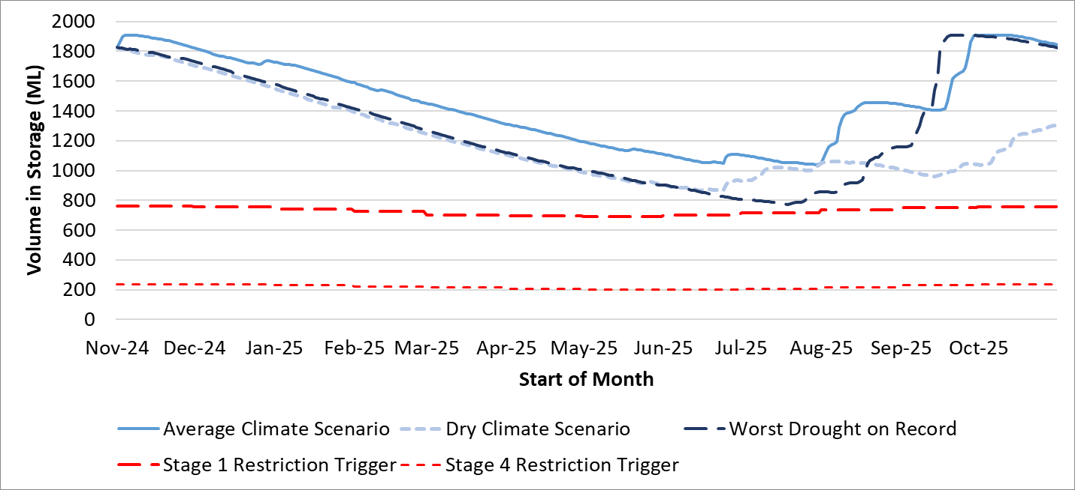

Figure 24 Urban water restrictions outlook for Leongatha

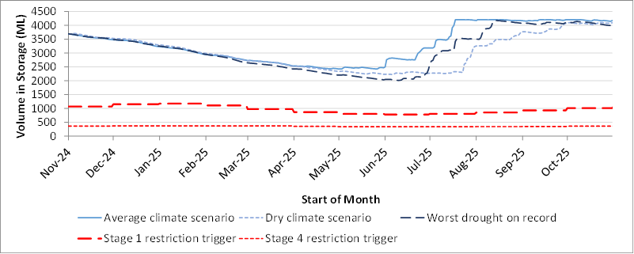

Figure 25 Urban water restrictions outlook for the Lance Creek system

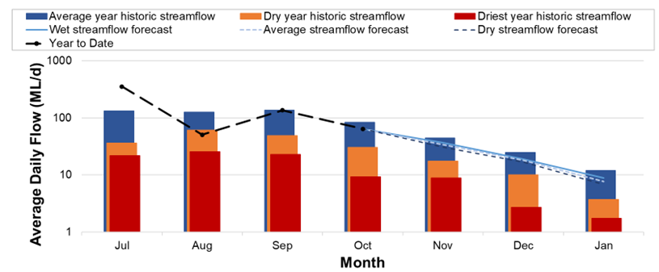

Figure 26 Streamflow outlook for Dumbalk

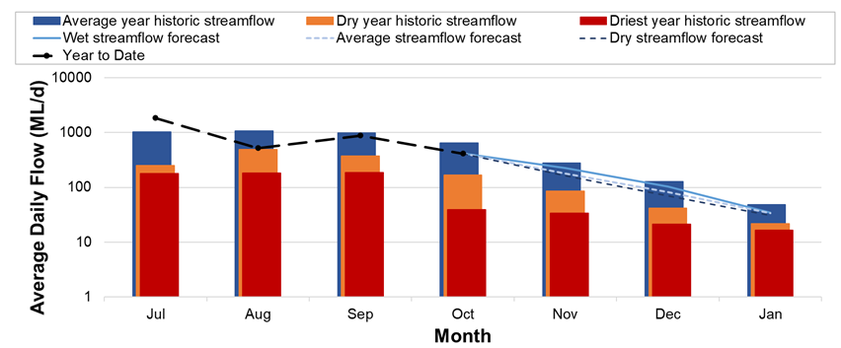

Figure 27 Streamflow outlook for Meeniyan

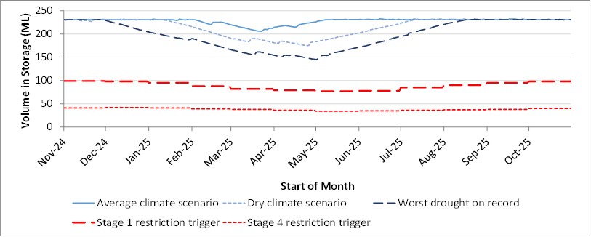

Figure 28 Urban water restrictions outlook for Foster

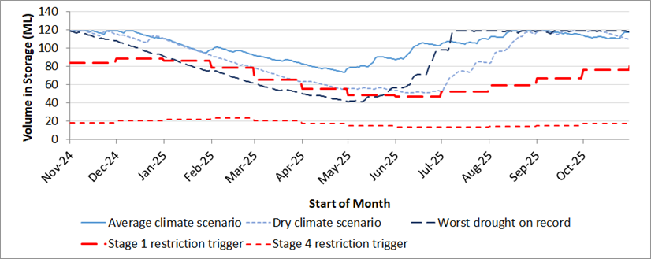

Figure 29 Urban water restrictions outlook for Fish Creek

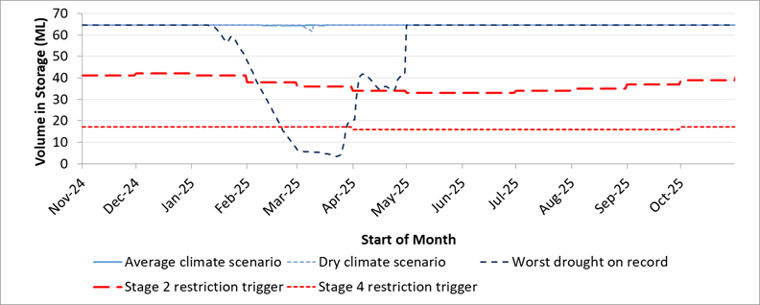

Figure 30 Urban water restrictions outlook for Toora

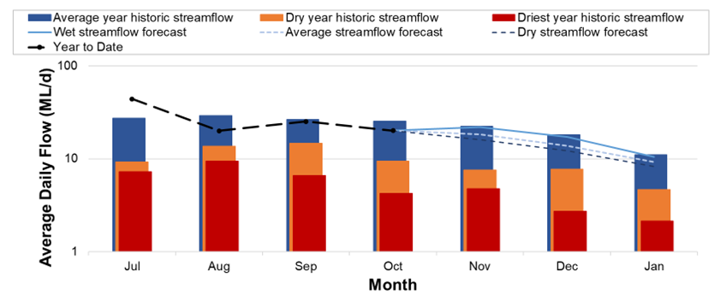

Figure 31 Streamflow outlook for Yarram

# 

# Short Term Action Plan

A list of priority actions for each of SGW’s supply systems, prior to the next update of the Urban Water Strategy in 2027, is provided in Table 9. Further information on actions can be found in the [2022 Urban Water Strategy](https://www.sgwater.com.au/about/about-us-home/urban-water-strategy/) and SGW’s [Price Submission 2023-2028](https://www.sgwater.com.au/about-us/water-plan/) publication on our website. Actions at Leongatha include investigating expanded use of groundwater and investigating the interconnection of disused reservoirs to improve reliability of supply at Leongatha. Since completing the Urban Water Strategy, South Gippsland Water has completed further investigations to assess the scope and costs of bringing some existing groundwater bores back into service and investigated the feasibility of stormwater capture and use to substitute non-potable demand.

Table 9 Priority Action Plan

|  |  |  |  |  |  |  |
| --- | --- | --- | --- | --- | --- | --- |
| **System** | **Action** | **Timing** | **Due date** | **Status** | **Progress** | **Comments** |
| Ruby Creek water system | Renew infrastructure to continue use of Condolucci, Wild Dog and Van Ecks groundwater bores | Next 5 years | 2027 | Completed | On Schedule | Scope, design, cost estimates completed. Reinstating bores identified as high cost per ML and no longer preferred approach to Leongatha water security. |
| Ruby Creek water system | Investigate connection to reinstate usage of Racecourse Road groundwater bore | Next 5 years | 2027 | Completed | On Schedule | Scope, design, cost estimates completed. Reinstating bores identified as high cost per ML and no longer preferred approach to Leongatha water security. |
| Ruby Creek water system | Investigate feasibility of interconnection of disused dams to the Ruby Creek system | Next 5 years | 2027 | Not Started | On Schedule |  |
| Lance Creek water system | Confirm strategy for purchase of additional Bulk Water Entitlement from Melbourne Water | Before 2023 | 2023 | In Progress | Rescheduled | Engagement with DEECA on South Central Reforms is underway. This reform process will determine when and how additional entitlement is purchased. |
| Lance Creek water system | Purchase additional Bulk Water Entitlement from Melbourne water supply system | By 2024 | 2024 | In Progress | Rescheduled | Engagement with DEECA on South Central Reforms is underway. This reform process will determine when and how additional entitlement is purchased. |
| Battery Creek water system | Investigate feasibility of digital meters to customers in Fish Creek to understand leakage and non-revenue water losses: Estimated 20% reduction in water losses. | Immediate | 2023 | In Progress | Rescheduled | Leak detection being planned for transfer and distribution mains in key towns using digital meters and flow balances rather than digital meters for customers in Fish Creek. |
| Baxters Beach wastewater system | Investigate a winter storage at Wonthaggi WWTP to enable the servicing of reuse demand | Before 2024 | 2024 | Completed | On Schedule |  |

Victoria’s [permanent water savings rules](https://www.sgwater.com.au/services/water/permanent-water-saving-rules/) are always in place in South Gippsland, saving water on an ongoing basis. For additional tips about how to save water see our [smart water advice](https://www.sgwater.com.au/smartwatermark).