**WATER SECURITY OUTLOOK**

**NOVEMBER 2024**

***Water Supply Information***

Water resources held by South Gippsland Water for the Meeniyan Water Supply System are shown below. Only 6% of the available annual entitlement has been used from the river in the current year to date (Jul-Sep 2024). This entitlement is a legal right to access water, subject to availability.

|  |  |  |  |
| --- | --- | --- | --- |
| Water Component | Maximum Annual  Entitlement | Volume Extracted 2024-25 | Volume Remaining 2024-25 |
| Tarwin River at Meeniyan | 200 ML | 12 ML | 188 ML |

***Water Consumption***

Monthly water consumption for the Meeniyan Water Supply System in the year to date has been above the average demand for August and September over the last five years. Higher demands are due to the fluctuation of demands in a small supply system. Water consumption is expected to remain close to the historical average for the remainder of the year.



***Meeniyan Water Supply System***

Meeniyan is supplied from the Tarwin River.

After diversion from the river, water is stored in a raw water basin prior to treatment and storage in a water tower. This water tower helps South Gippsland Water to maintain supply during peak demand periods in the morning and evening.

South Gippsland Water

1300 851 636

www.sgwater.com.au

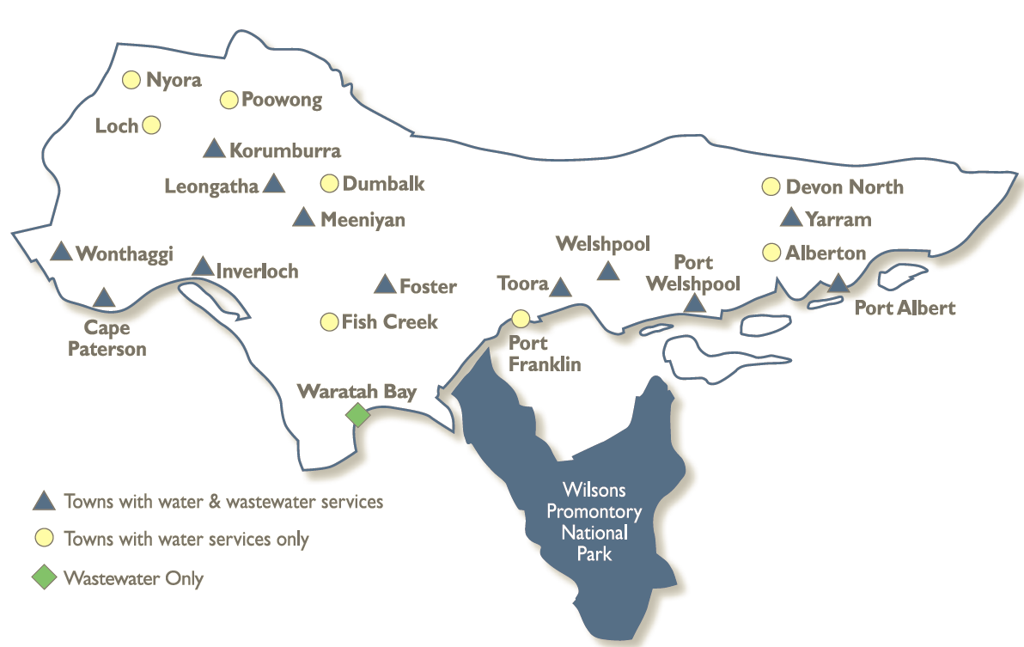

**WATER SECURITY OUTLOOK**

**NOVEMBER 2024**

***Climate Conditions***

Forecast climate conditions for the coming three months have considered the Bureau of Meteorology’s seasonal climate forecast for the region and local climate conditions in the year to date. Winter/spring rainfall in the year to date has consistent with the long-term average, and the Bureau’s climate outlook indicates that the next three months are likely to be slightly wetter than usual. Air temperature is forecast over the next three months to be warmer than usual for this time of year, and this trend is expected to continue beyond this period. After taking these factors into account, South Gippsland Water is forecasting on the basis of an average climate scenario.

|  |  |  |  |
| --- | --- | --- | --- |
| Chance of Exceeding Median Rainfall | Chance of Exceeding Median Maximum Temperature | This Year’s Winter/Spring Rainfall | Likely Outlook Scenario |
| 65-70% | **Greater than 80**% | **Average** | **Average** |

**Further Information:**

* The most recent records for the Tarwin River at Meeniyan show that it was flowing at an average of 415 ML/d during October. This is well above SGW’s restriction trigger of 5 ML/d
* Unregulated river flows are difficult to forecast. SGW has only forecast the next 3 months due to low forecast skill beyond 3 months. The graph is formatted to highlight low flow behaviour.
* Units are in megalitres per day (ML/d), where 1 ML is equivalent to 1 million litres.

***Streamflow Outlook***

Streamflow in the Tarwin River is naturally highly variable. For the year to date, streamflow has been around the long-term average. Water restrictions have previously only been enacted during extreme drought. Whilst precisely forecasting streamflow conditions is difficult, streamflow for the outlook period is currently expected to remain close to average if average climate conditions eventuate as expected. River flows are expected to remain above the 5 ML/d trigger for restrictions.

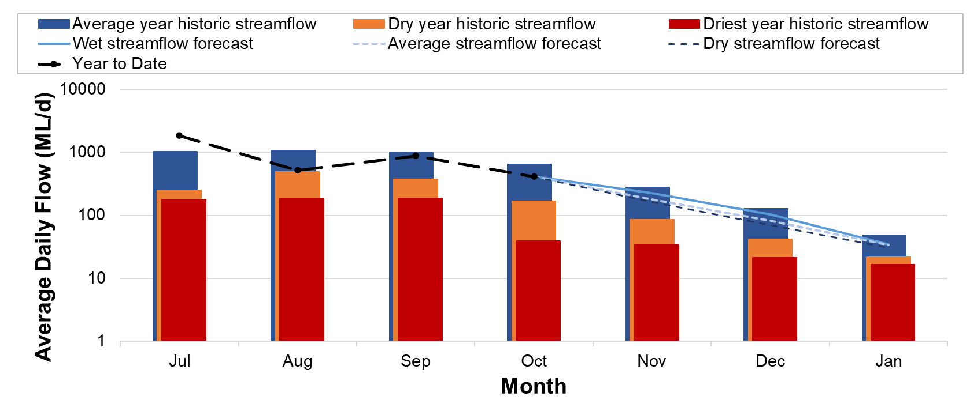

South Gippsland Water

1300 851 636

www.sgwater.com.au

**WATER SECURITY OUTLOOK**

**NOVEMBER 2024**

***Urban Water Restrictions Outlook***

Based on the recent streamflow record, the Bureau of Meteorology climate forecast and SGW’s daily streamflow forecast, no water restrictions are anticipated over the outlook period at the current time. South Gippsland Water’s Permanent Water Savings Plan applies to all customers over the outlook period.

|  |  |  |  |
| --- | --- | --- | --- |
| **Climate Scenario** | **Outlook** | | |
| **1 Dec 2024** | **1 Jan 2025** | **1 Feb 2025** |
| Wet | PWSP | PWSP | PWSP |
| Average | PWSP | PWSP | PWSP |
| Dry | PWSP | PWSP | PWSP |

PWSP Permanent Water Savings Plan

***Action Plan***

A list of priority actions for this supply system prior to the next update of the Urban Water Strategy in 2027 is presented below. Further information on actions can be found in our [2022 Urban Water Strategy](https://www.sgwater.com.au/about/about-us-home/urban-water-strategy/) and our [Price Submission 2023-2028](https://www.sgwater.com.au/about-us/water-plan/) publication on our website. Victoria’s [permanent water savings rules](https://www.sgwater.com.au/services/water/permanent-water-saving-rules/) are always in place in South Gippsland, saving water on an ongoing basis. For additional tips about how to save water see our [smart water advice](https://www.sgwater.com.au/smartwatermark).

|  |  |
| --- | --- |
| **Action Name** | **Timing** |
| Water awareness and efficiency programs | Ongoing |
| Leak reduction | Ongoing |
| Reuse opportunities | Ongoing |
| Update water security outlook | Every November |
| Planning for long term options as per the Urban Water Strategy | 2022-2027 |

The information provided in this water security outlook is intended as a guide only. An update will be issued if conditions change during the outlook period.

South Gippsland Water

1300 851 636

www.sgwater.com.au

***Blah***

***Water Consumption***

Lance Creek Water Supply System monthly actual water consumption versus historical consumption

***Table***

***Water Supply Information***

Water resources held by South Gippsland Water for the Lance Creek Water Supply System