**WATER SECURITY OUTLOOK**

**NOVEMBER 2024**

***Water Consumption***

Monthly water consumption for the Leongatha Water Supply System in the year to date has been below the average demand over the last five years. This is primarily due to water use by major customers being 28% lower over the year to date, relative to the last 5 years.



***Water Supply Information***

Water resources held by South Gippsland Water for the Leongatha Water Supply System are shown below. Only 13% of the available annual entitlement from the Leongatha storages has been used in the current year to date (Jul-Sep 2024). This entitlement is a legal right to access water, subject to availability. No water has been diverted to the Leongatha storages from the local groundwater bore.

|  |  |  |  |
| --- | --- | --- | --- |
| Water Component | Maximum Annual  Entitlement | Volume Extracted 2024-25 | Volume Remaining 2024-25 |
| No.1, No. 2, Hyland and Western Reservoirs | 2,476 ML | 335 ML | 2,141 ML |

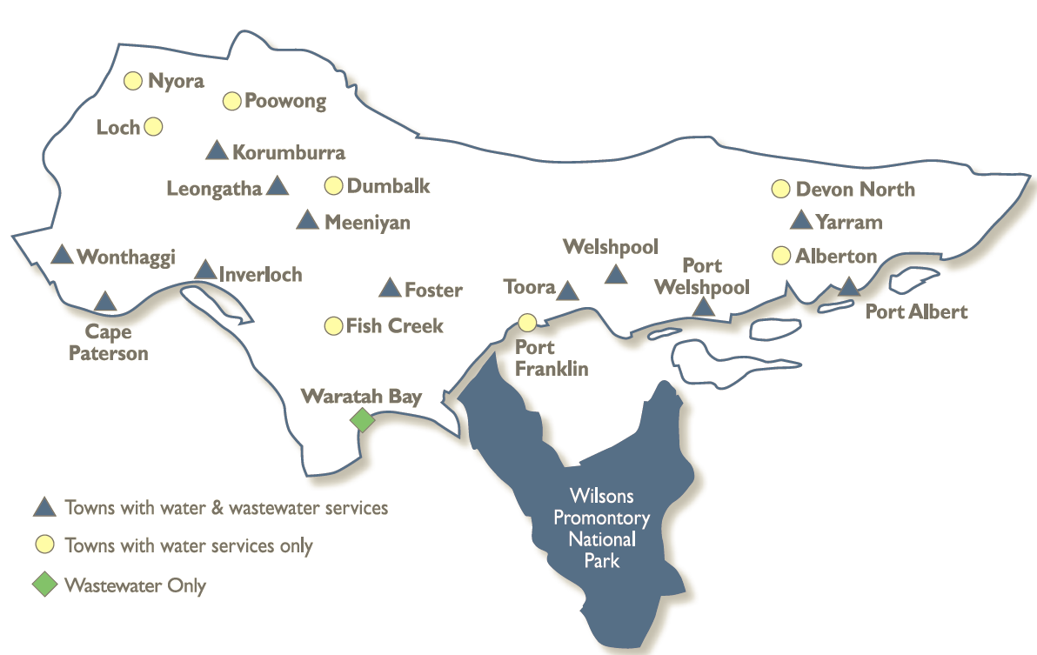

The town of Leongatha receives its primary water supply from four storages on Ruby Creek:

* Western Reservoir: 1,137 ML capacity
* Hyland Reservoir: 671 ML capacity
* No.2 Reservoir: 84 ML capacity
* No. 1 Reservoir: 11 ML capacity

Alternative supply during drought is also available from local groundwater bores, although these haven’t been used since 2007 and require refurbishment before they can be used in the future.

***Leongatha Water Supply System***

South Gippsland Water

1300 851 636

www.sgwater.com.au

**WATER SECURITY OUTLOOK**

**NOVEMBER 2024**

***Climate Conditions***

Forecast climate conditions for the coming three months have considered the Bureau of Meteorology’s seasonal climate forecast for the region and local climate conditions in the year to date. Winter/spring rainfall in the year to date has consistent with the long-term average, and the Bureau’s climate outlook indicates that the next three months are likely to be slightly wetter than usual. Air temperature is forecast over the next three months to be warmer than usual for this time of year, and this trend is expected to continue beyond this period. After taking these factors into account, South Gippsland Water is forecasting on the basis of an average climate scenario.

|  |  |  |  |
| --- | --- | --- | --- |
| Chance of Exceeding Median Rainfall | Chance of Exceeding Median Maximum Temperature | This Year’s Winter/Spring Rainfall | Likely Outlook Scenario |
| 65-70% | **Greater than 80**% | **Average** | **Average** |

**Further Information:**

* Western Reservoir and No.1 Reservoir was at full capacity at the end of October.
* Hyland Reservoir was at 91% and No.2 Reservoir at 71% of full capacity at the end of October
* Volumes shown in the storage outlook are start of month values in megalitres (ML), where 1 ML is equivalent to 1 million litres.

***Urban Water Restrictions Outlook***

The volume in storage outlook for the Leongatha Water Supply System for the period November 2024 to October 2025 indicates that storage levels are expected to remain above water restriction triggers over the coming year under the anticipated dry climate scenario.

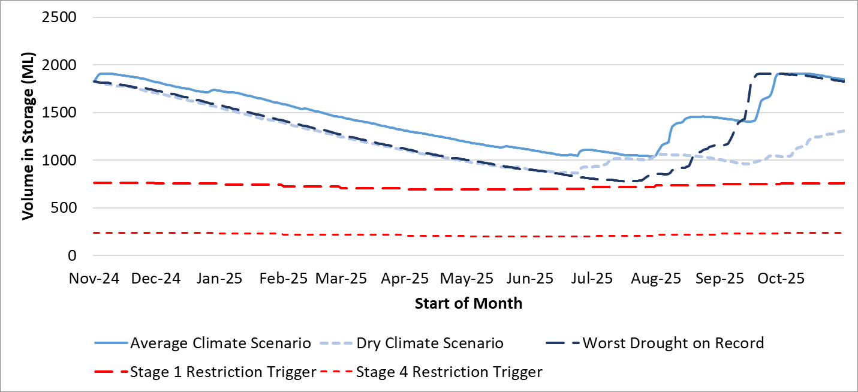

Based on the volume in storage outlook and the Bureau of Meteorology climate forecast, no water restrictions are anticipated for the remainder of the year at the current time. South Gippsland Water’s Permanent Water Savings Plan applies to all customers over the outlook period.

|  |  |  |  |
| --- | --- | --- | --- |
| **Climate Scenario** | **Outlook** | | |
| **1 Jan 2025** | **1 Apr 2025** | **1 Jul 2025** |
| Wet | PWSP | PWSP | PWSP |
| Average | PWSP | PWSP | PWSP |
| Dry | PWSP | PWSP | PWSP |

PWSP Permanent Water Savings Plan

South Gippsland Water

1300 851 636

www.sgwater.com.au

**WATER SECURITY OUTLOOK**

**NOVEMBER 2024**

***Action Plan***

A list of priority actions for this supply system prior to the next update of the Urban Water Strategy in 2027 is presented below. The Urban Water Strategy identified that the Leongatha system is not able to meet South Gippsland Water’s long-term target service criteria for restrictions, and water restrictions can be expected on average once every 3-5 years (depending on climate change assumptions). However storages are currently full and supplementary sources of water are available and ready to use if needed.

Further information on actions can be found in our [2022 Urban Water Strategy](https://www.sgwater.com.au/about/about-us-home/urban-water-strategy/) and our [Price Submission 2023-2028](https://www.sgwater.com.au/about-us/water-plan/) publication on our website. Actions at Leongatha include investigating expanded use of groundwater and investigating the interconnection of disused reservoirs to improve reliability of supply at Leongatha. Since completing the Urban Water Strategy, South Gippsland Water has completed further investigations to assess the scope and costs of bringing some existing groundwater bores back into service, for comparison against other options.

|  |  |
| --- | --- |
| **Action Name** | **Timing** |
| Water awareness and efficiency programs | Ongoing |
| Leak reduction | Ongoing |
| Reuse opportunities | Ongoing |
| Update water security outlook | Every November |
| Planning for long term options as per the Urban Water Strategy | 2022-2027 |

Victoria’s [permanent water savings rules](https://www.sgwater.com.au/services/water/permanent-water-saving-rules/) are always in place in South Gippsland, saving water on an ongoing basis. For additional tips about how to save water see our [smart water advice](https://www.sgwater.com.au/smartwatermark).

The information provided in this water security outlook is intended as a guide only. An update will be issued if conditions change during the outlook period.

South Gippsland Water

1300 851 636

www.sgwater.com.au

***Blah***

***Water Consumption***

Lance Creek Water Supply System monthly actual water consumption versus historical consumption

***Table***

***Water Supply Information***

Water resources held by South Gippsland Water for the Lance Creek Water Supply System