**WATER SECURITY OUTLOOK**

**NOVEMBER 2024**

Lance Creek Water Supply System supplies water to the townships of:

* Wonthaggi
* Cape Paterson
* Inverloch
* Korumburra
* Poowong
* Loch
* Nyora

The Lance Creek Supply System includes the following water sources:

* Lance Creek Reservoir: 4,200ML capacity
* Greater Yarra System – Thomson River Pool: 1,000 ML entitlement plus any unused water carried over from previous years

South Gippsland Water

1300 851 636

www.sgwater.com.au

***Water Supply Information***

Water resources held by South Gippsland Water for the Lance Creek Water Supply System are shown below. In the year to date (Jul-Sep 2024) 17% of the available annual entitlement from Lance Creek Reservoir has been used. This entitlement is a legal right to access water, subject to availability.

A significant supply volume is also available to the Lance Creek Water Supply System from the Greater Yarra System – Thomson River Pool (Melbourne Water Supply System). South Gippsland Water has been allocated 31% of its entitlement from the Melbourne Water Supply System in the year to date. Based on projections by Melbourne Water, this year’s allocation is expected to increase over the coming months, even under the forecast average dry conditions (see overleaf) over the outlook period. South Gippsland Water has also carried over 1,737 ML of unused allocations from previous years to the current year, providing a significant supply buffer in this supply system if conditions were to become drier than expected. Only 5% of South Gippsland Water’s total available volume from the Melbourne Water Supply System has been used in the year to date.

|  |  |  |  |  |  |  |
| --- | --- | --- | --- | --- | --- | --- |
| Water Component | Maximum Annual  Entitlement | Year To Date Allocation | Carryover from Last Year* | Allocation Plus Carryover | Volume Extracted 2024-25 | Volume Remaining 2024-25 |
| Lance Creek Reservoir | 3,800 ML | N/a | N/a | N/a | 645 ML | 3,155 ML |
| Melbourne Water Supply System | 1,000 ML | 310 ML | 1,728 ML | 2,038 ML | 123 ML | 1,915 ML |

*After deductions for reservoir spills in the Melbourne Water Supply System

***Lance Creek Water Supply System***

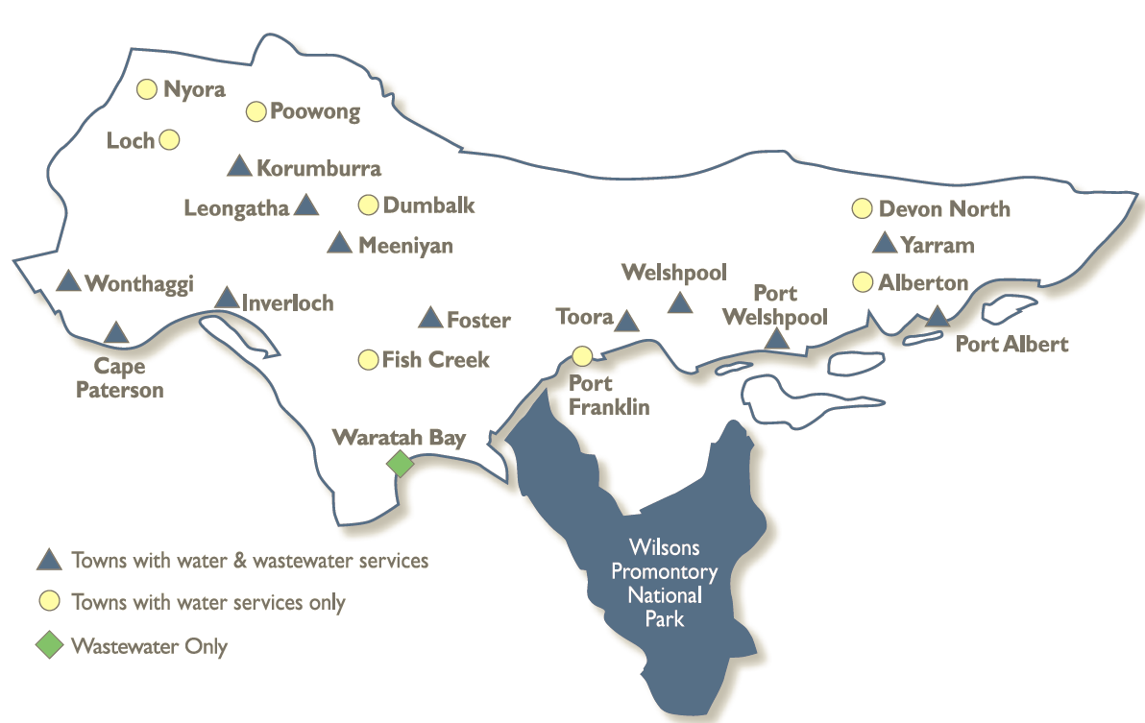

**WATER SECURITY OUTLOOK**

**NOVEMBER 2024**

***Water Consumption***

Water consumption for the Lance Creek Water Supply System in the year to date has been above the average demand over the last five years. The higher year to date demand is partly due to increased water use from one of the major industrial users. It is expected that the demand will be closer to the historical average for the remainder of the year.



***Climate Conditions***

Forecast climate conditions for the coming three months have considered the Bureau of Meteorology’s seasonal climate forecast for the region and local climate conditions in the year to date. Winter/spring rainfall in the year to date has been less than the long-term average, and the Bureau’s climate outlook indicates that the next three months are likely to be slightly wetter than usual. Air temperature is forecast over the next three months to be warmer than usual for this time of year, and this trend is expected to continue beyond this period. After taking these factors into account, South Gippsland Water is forecasting on the basis of an average climate scenario

|  |  |  |  |
| --- | --- | --- | --- |
| Chance of Exceeding Median Rainfall | Chance of Exceeding Median Maximum Temperature | This Year’s Winter/Spring Rainfall | Likely Outlook Scenario |
| 65-70% | **Greater than 80**% | **Less than average** | **Average** |

South Gippsland Water

1300 851 636

www.sgwater.com.au

**WATER SECURITY OUTLOOK**

**NOVEMBER 2024**

**Further Information:**

* Lance Creek Reservoir was 88% full at the end of October.
* Volumes shown in the storage outlook are start of month values in megalitres (ML), where 1 ML is equivalent to 1 million litres.

***Urban Water Restrictions Outlook***

The volume in storage outlook for Lance Creek Reservoir for the period November 2024 to October 2025 indicates that storage levels are expected to remain high relative to water restriction triggers over the coming year.



Based on the volume in storage outlook and the Bureau of Meteorology climate forecast, no water restrictions are anticipated for the remainder of the year at the current time. South Gippsland Water’s Permanent Water Savings Plan applies to all customers over the outlook period.

|  |  |  |  |
| --- | --- | --- | --- |
| **Climate Scenario** | **Outlook** | | |
| **1 Jan 2025** | **1 Apr 2025** | **1 Jul 2025** |
| Wet | PWSP | PWSP | PWSP |
| Average | PWSP | PWSP | PWSP |
| Dry | PWSP | PWSP | PWSP |

PWSP Permanent Water Savings Plan

***Action Plan***

A list of priority actions for this supply system prior to the next update of the Urban Water Strategy in 2027 is presented below. Further information on actions can be found in our [2022 Urban Water Strategy](https://www.sgwater.com.au/about/about-us-home/urban-water-strategy/) and our [Price Submission 2023-2028](https://www.sgwater.com.au/about-us/water-plan/) publication on our website. Victoria’s [permanent water savings rules](https://www.sgwater.com.au/services/water/permanent-water-saving-rules/) are always in place in South Gippsland, saving water on an ongoing basis. For additional tips about how to save water see our [smart water advice](https://www.sgwater.com.au/smartwatermark).

|  |  |
| --- | --- |
| **Action Name** | **Timing** |
| Water awareness and efficiency programs | Ongoing |
| Leak reduction | Ongoing |
| Reuse opportunities | Ongoing |
| Update water security outlook | Every November |

The information provided in this water security outlook is intended as a guide only. An update will be issued if conditions change during the outlook period.

South Gippsland Water

1300 851 636

www.sgwater.com.au

***Blah***

***Water Consumption***

Lance Creek Water Supply System monthly actual water consumption versus historical consumption

***Table***

***Water Supply Information***

Water resources held by South Gippsland Water for the Lance Creek Water Supply System