**WATER SECURITY OUTLOOK**

**NOVEMBER 2024**

***Water Consumption***

Monthly water consumption for the Fish Creek Water Supply System in the year to date has been below the average demand over the last five years. It is expected that demand will be close to the historical average for the remainder of the year.



***Water Supply Information***

Water resources held by South Gippsland Water for the Fish Creek Water Supply System are shown below. Approximately 10% of the available annual entitlement has been used from Battery Creek Reservoir in the current year to date (Jul-Sep 2024). This entitlement is a legal right to access water, subject to availability.

|  |  |  |  |
| --- | --- | --- | --- |
| Water Component | Maximum Annual  Entitlement | Volume Extracted 2024-25 | Volume Remaining 2024-25 |
| Battery Creek Reservoir | 251 ML | 26 ML | 225 ML |

The town of Fish Creek receives its water supply from Battery Creek Reservoir, located on Battery Creek. The reservoir has a capacity of 123 ML and allows water harvested in winter/spring to be stored and then supplied to customers in summer/autumn.

The Fish Creek water supply system also provides water supply to rural customers, who account for approximately 40% of total supply system demand in an average year.

***Fish Creek Water Supply System***

South Gippsland Water

1300 851 636

www.sgwater.com.au

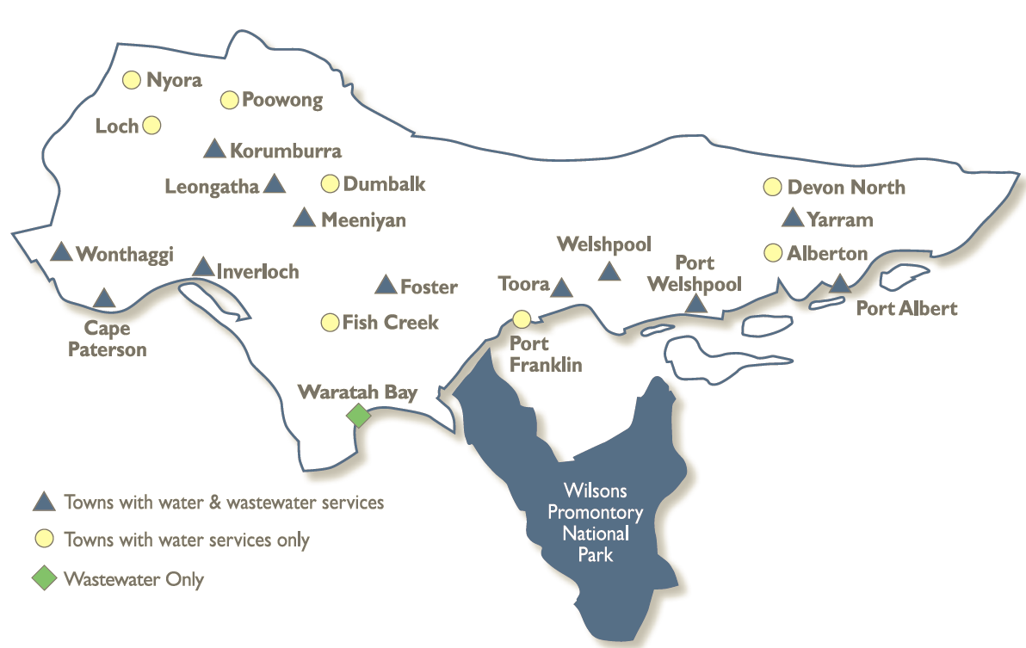

**WATER SECURITY OUTLOOK**

**NOVEMBER 2024**

***Climate Conditions***

Forecast climate conditions for the coming three months have considered the Bureau of Meteorology’s seasonal climate forecast for the region and local climate conditions in the year to date. Winter/spring rainfall in the year to date has consistent with the long-term average, and the Bureau’s climate outlook indicates that the next three months are likely to be slightly wetter than usual. Air temperature is forecast over the next three months to be warmer than usual for this time of year, and this trend is expected to continue beyond this period. After taking these factors into account, South Gippsland Water is forecasting on the basis of an average climate scenario.

|  |  |  |  |
| --- | --- | --- | --- |
| Chance of Exceeding Median Rainfall | Chance of Exceeding Median Maximum Temperature | This Year’s Winter/Spring Rainfall | Likely Outlook Scenario |
| 65-70% | **Greater than 80**% | **Average** | **Average** |

**Further Information:**

* Battery Creek Reservoir was 100% full at the end of October.
* Volumes shown in the storage outlook are start of month values in megalitres (ML), where 1 ML is equivalent to 1 million litres.

***Urban Water Restrictions Outlook***

The volume in storage outlook for Battery Creek Reservoir for the period November 2024 to October 2025 indicates that storage levels are not expected to reach the water restriction triggers over the coming year under the anticipated average climate scenario.

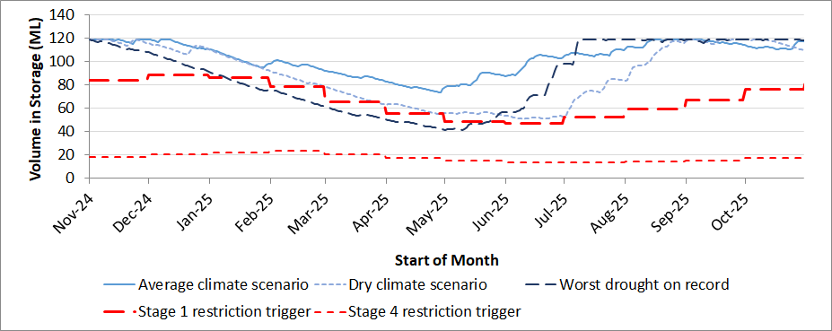

Based on the volume in storage outlook and the Bureau of Meteorology climate forecast, restrictions are not expected under the anticipated average climate scenario, but could still be possible in late summer and autumn if conditions were to become drier than anticipated. Fish Creek (Battery Creek Storage) is a small system and can change quickly, both in response to rainfall, and in the event of sustained dry conditions for only a few months. South Gippsland Water’s Permanent Water Savings Plan applies to all customers over the outlook period.

|  |  |  |  |
| --- | --- | --- | --- |
| **Climate Scenario** | **Outlook** | | |
| **1 Jan 2025** | **1 Apr 2025** | **1 Jul 2025** |
| Wet | PWSP | PWSP | PWSP |
| Average | PWSP | PWSP | PWSP |
| Dry | PWSP | Stage 1 | PWSP |

PWSP Permanent Water Savings Plan

South Gippsland Water

1300 851 636

www.sgwater.com.au

**WATER SECURITY OUTLOOK**

**NOVEMBER 2024**

***Action Plan***

A list of priority actions for this supply system prior to the next update of the Urban Water Strategy in 2027 is presented below. Further information on actions can be found in our [2022 Urban Water Strategy](https://www.sgwater.com.au/about/about-us-home/urban-water-strategy/) and our [Price Submission 2023-2028](https://www.sgwater.com.au/about-us/water-plan/) publication on our website. Victoria’s [permanent water savings rules](https://www.sgwater.com.au/services/water/permanent-water-saving-rules/) are always in place in South Gippsland, saving water on an ongoing basis. For additional tips about how to save water see our [smart water advice](https://www.sgwater.com.au/smartwatermark).

|  |  |
| --- | --- |
| **Action Name** | **Timing** |
| Water awareness and efficiency programs | Ongoing |
| Leak reduction | Ongoing |
| Reuse opportunities | Ongoing |
| Update water security outlook | Every November |
| Planning for long term options as per the Urban Water Strategy | 2022-2027 |

The information provided in this water security outlook is intended as a guide only. An update will be issued if conditions change during the outlook period.

South Gippsland Water

1300 851 636

www.sgwater.com.au

***Blah***

***Water Consumption***

Lance Creek Water Supply System monthly actual water consumption versus historical consumption

***Table***

***Water Supply Information***

Water resources held by South Gippsland Water for the Lance Creek Water Supply System