**WATER SECURITY OUTLOOK**

**NOVEMBER 2024**

***Water Supply Information***

Water resources held by South Gippsland Water for the Dumbalk Water Supply System are shown below. Only 3% of the available annual entitlement has been used from the river in the current year to date (Jul-Sep 2024). This entitlement is a legal right to access water, subject to availability.

|  |  |  |  |
| --- | --- | --- | --- |
| Water Component | Maximum Annual  Entitlement | Volume Extracted 2024-25 | Volume Remaining 2024-25 |
| Tarwin River at Dumbalk | 100 ML | 3 ML | 97 ML |

***Water Consumption***

Monthly water consumption for the Dumbalk Water Supply System in the year to date was below average in July and September and average in August. It is expected that demand will be close to the historical average for the remainder of the year.



***Dumbalk Water Supply System***

Dumbalk is supplied from the Tarwin River East Branch.

After diversion from the river, water is stored in a small raw water storage tank and treated. Water is stored in a water tower. The raw water storage is designed to manage water quality and isn’t large enough to significantly benefit water security.

South Gippsland Water

1300 851 636

www.sgwater.com.au

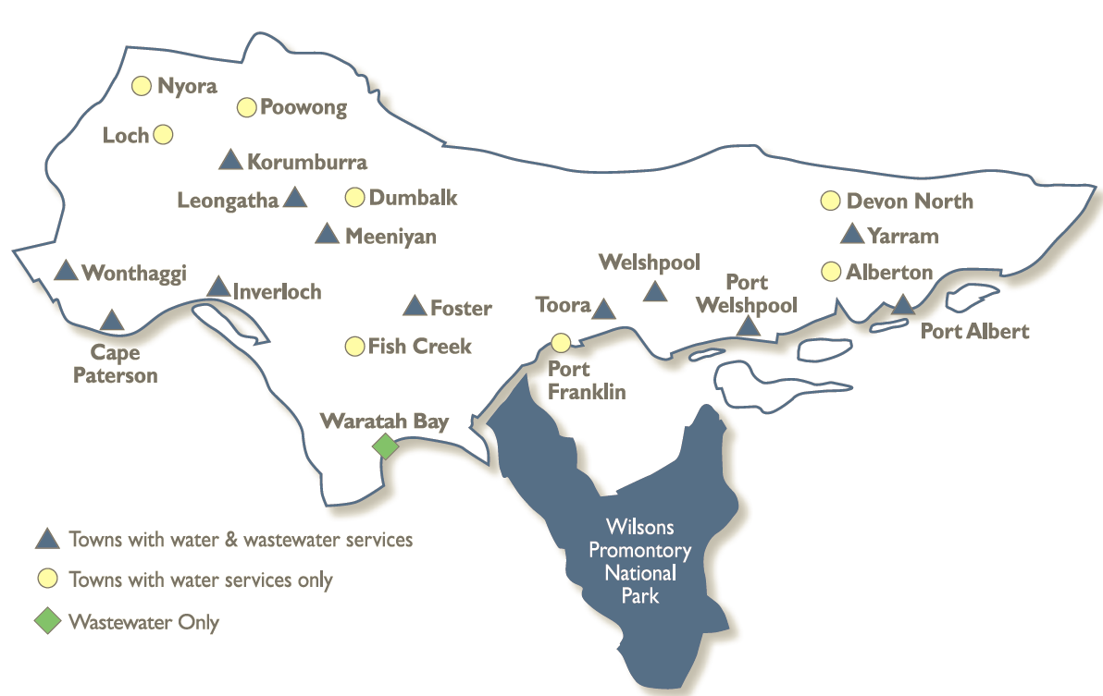

**WATER SECURITY OUTLOOK**

**NOVEMBER 2024**

***Climate Conditions***

Forecast climate conditions for the coming three months have considered the Bureau of Meteorology’s seasonal climate forecast for the region and local climate conditions in the year to date. Winter/spring rainfall in the year to date has consistent with the long-term average, and the Bureau’s climate outlook indicates that the next three months are likely to be slightly wetter than usual. Air temperature is forecast over the next three months to be warmer than usual for this time of year, and this trend is expected to continue beyond this period. After taking these factors into account, South Gippsland Water is forecasting on the basis of an average climate scenario.

|  |  |  |  |
| --- | --- | --- | --- |
| Chance of Exceeding Median Rainfall | Chance of Exceeding Median Maximum Temperature | This Year’s Winter/Spring Rainfall | Likely Outlook Scenario |
| 65-70% | **Greater than 80**% | **Average** | **Average** |

**Further Information:**

* The most recent records for the Tarwin River East Branch at Dumbalk show that it was flowing at an average of 64 ML/d during October. This is well above SGW’s restriction trigger of 1 ML/d.
* Unregulated river flows are difficult to forecast. SGW has only forecast the next 3 months due to low forecast skill beyond 3 months. The graph is formatted to highlight low flow behaviour.
* Units are in megalitres per day (ML/d), where 1 ML is equivalent to 1 million litres.

***Streamflow Outlook***

Streamflows in the Tarwin River are naturally highly variable. For the year to date, streamflow has generally been at or slightly below the long-term average. Whilst precisely forecasting streamflow conditions is difficult, streamflow for the outlook period is currently expected to remain around the historical average even if slightly drier conditions occur over the coming months. Water restrictions have previously only been enacted at Dumbalk during extreme drought. River flows are expected to remain above SGW’s 1 ML/d trigger for restrictions over the outlook period.

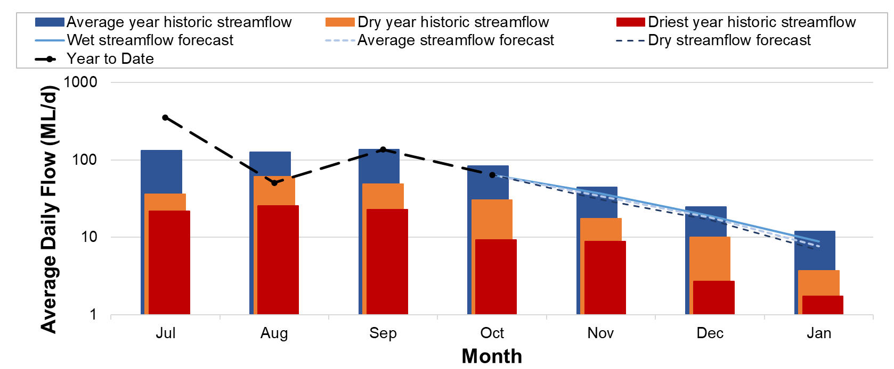

***Urban Water Restrictions Outlook***

Based on the recent streamflow record, average demands for water expected for the next three months, the Bureau of Meteorology climate forecast and SGW’s daily streamflow forecast, no water restrictions are anticipated over the outlook period at the current time. South Gippsland Water’s Permanent Water Savings Plan applies to all customers over the outlook period.

|  |  |  |  |
| --- | --- | --- | --- |
| **Climate Scenario** | **Outlook** | | |
| **1 Dec 2024** | **1 Jan 2025** | **1 Feb 2025** |
| Wet | PWSP | PWSP | PWSP |
| Average | PWSP | PWSP | PWSP |
| Dry | PWSP | PWSP | PWSP |

PWSP Permanent Water Savings Plan

South Gippsland Water

1300 851 636

www.sgwater.com.au

**WATER SECURITY OUTLOOK**

**NOVEMBER 2024**

***Action Plan***

A list of priority actions for this supply system prior to the next update of the Urban Water Strategy in 2027 is presented below. Further information on actions can be found in our [2022 Urban Water Strategy](https://www.sgwater.com.au/about/about-us-home/urban-water-strategy/) and our [Price Submission 2023-2028](https://www.sgwater.com.au/about-us/water-plan/) publication on our website. Victoria’s [permanent water savings rules](https://www.sgwater.com.au/services/water/permanent-water-saving-rules/) are always in place in South Gippsland, saving water on an ongoing basis. For additional tips about how to save water see our [smart water advice](https://www.sgwater.com.au/smartwatermark).

|  |  |
| --- | --- |
| **Action Name** | **Timing** |
| Water awareness and efficiency programs | Ongoing |
| Leak reduction | Ongoing |
| Update water security outlook | Every November |
| Planning for long term options as per the Urban Water Strategy | 2022-2027 |

The information provided in this water security outlook is intended as a guide only. An update will be issued if conditions change during the outlook period.

South Gippsland Water

1300 851 636

www.sgwater.com.au

***Blah***

***Water Consumption***

Lance Creek Water Supply System monthly actual water consumption versus historical consumption

***Table***

***Water Supply Information***

Water resources held by South Gippsland Water for the Lance Creek Water Supply System